Antiretroviral therapy. TAJIKISTAN

EPIDEMIOLOGICAL CONTEXT

Prevalence and spread of HIV infection, AIDS and AIDS mortality.
The estimated number of PWLH constituted 14 000 persons in 2013. The indicator of HIV infection decreased from 2011 to 2013 according to surveillance data. The incidence and prevalence of HIV infection among general population and risk groups imply stabilization of the epidemiological process in the Republic of Tajikistan (Table 1).

TABLE 1. MAIN EPIDEMIOLOGICAL INDICATORS

 | 2011 | 2013
The estimated number of PWLH | 12 720 | 14 000
HIV prevalence among adults (at the age of 15-49 years old), % | 0.19 | 0.23
HIV spread among PWID according to sentinal surveillance data, % | 16.3 | 12.8
HIV prevalence among MSM according to sentinal surveillance data, % | 1.5 | n/d
HIV prevalence among CSW according to sentinal surveillance data, % | 4.4 | 3.5
The number of newly registered cases of HIV infection | 989 | 876
HIV incidence per 100 000 people | 12.8 | 10.9
Percentage of officially registered PWLH from the estimated number, % | 26 | 32.7
AIDS case rate per 100 000 people | 1.01 | 1.6
AIDS related death per 100 000 people | 2 | 0.77

In 2013 the number of officially registered PWLH was 32.7% from the estimated number of PWLH in the country.
Against the background of increased access to ART, AIDS related mortality has decreased. However, late HIV diagnostic does not allow to stabilize or improve AIDS incidence.

HIV TESTING ACCESSIBILITY
In 2013 the overall number of HIV tests was 517 394 which meant that there were 6 340 tests per 100 000 people. There is also increase in number of representatives from key highly vulnerable groups who received/went through voluntary counseling and testing (VCT). In 2011 there were 5362 PWID tested for HIV (21% from the estimated number of PWID), and in 2013 this number was 9710 (38% from the estimated number of PWID) (Table 2).
Over the last years HIV testing coverage among MSM has been at a very low level. In 2013 this number was 1.6 % from the estimated number of МSМ tested for HIV. HIV testing coverage among CSW increased from 4333 (34%) from the estimated number of CSW in 2011 up to 7309 (58%) in 2013.

TABLE 2. HIV TESTING INDICATORS
 | 2011 | 2013
The overall number of HIV tests per 100 000 people | 6 354 | 6 340
The number of HIV tests among key vulnerable groups
PWID | 5362 | 9710
CSW | 4333 | 7309
МSМ | 790 | 538
migrants | 67 166 | 29 331
% of pregnant women tested for HIV over the last 12 months and aware of their results | 79 | 75
% of patients with TB aware of their HIV positive status | 82 | 92(2012)
In Tajikistan the level of HIV testing coverage among pregnant women decreased from 79% in 2011 to 75% in 2013. In 2013 HIV testing among patients with TB aware of their results reached 92%.

The number of tests among migrants considerably decreased while their percentage remains rather high in relation to other key population groups.

ACCESS TO ARV THERAPY

In the Republic of Tajikistan there are 38 health care institutions providing ART. 36 health care institutions providing treatment to PWLH diagnose tuberculosis. At the end of 2013 the number of PWID receiving ARV therapy alongside with substitution maintenance therapy constituted 46 people. There are no institutions in the country providing integrated services to HIV positive PWID. But at present there have been negotiations aiming at providing integrated services in the country.
In 2011-2013 scale up of access to ART from 713 to 1145 among adult PWLH was observed. But it should be noted that in 2013 the total ART coverage was 9 % from the estimated number of PWLH in the country and has shown a tendency to increase (comparing to 11,1% in 2011). In 2013 1145 PWLH out of 2 717 adult patients of the dispensary group (42 %) received ARV therapy. The following number is attributed to those PWLH who visited health care institutions at least once in the following year (Table 3).

TABLE 3. ACCESS TO ARV THERAPY AND MEDICAL FOLLOW UP

 | 2011 | 2012 | 2013
The number of adults (at the age of 15+) receiving ARV therapy at the end of the year | 713 | 895 | 1145
Percentage of adults (at the age of 15+) receiving ARV therapy from the estimated number of PWLH, % | 5.58 | 7.45 | 8.95
Adults’ percentage (at the age of 15+) receiving ARV therapy from the number of the dispensary group, % | 38 | 35 | 42
The number of PWID receiving ART | No data available
The number of representatives from other key vulnerable groups receiving ART | No data available
Percentage of PWID among adults (at the age of 15+) receiving ARV therapy | No data available
Percentage of representatives from other key vulnerable groups receiving ART | No data available
The number of HIV infected PWID receiving ARV and substitution therapy | 43 | 46 | 46
Percentage of PWLH tested for CD4 level at the moment of diagnosing the case (in the course of 2 months after diagnosing the case), % | 39 | 34.6 | 45
Percentage of PWLH with the clinical symptoms and CD4 < 350 at the moment of diagnosing the case*, % | 21 | 23.3 | 26.7
The average level of CD4 among patients at the moment of starting ARV therapy | No data available*
*Available data on the average level of CD4 at the moment of registering an HIV positive person. Indicators of the average meaning of CD4 at the moment of registering were as follows: in 2011 the indicator was 213 cells/mcl, in 2012 it was 214 cells/mcl, and in 2013 it was 117 cells/mcl.
The current National Clinical Protocols approved by the Ministry of Health prescribe systematic monitoring of the level of CD4 for all HIV patients which helps to solve the issues related to the start of ARV therapy as well as opportunistic infections prevention.
In compliance with the National Protocol the immunological threshold for starting ARV therapy was at the level of CD4 < 350 cells/mcl in 2013.
The percentage of PWLH with the clinical symptoms or the number of CD4 <350 cells/mcl at the moment of diagnosing HIV infection constituted 26,7% in 2013. Simplified technologies of identifying the level of CD4 are unavailable at the level of diagnosing HIV infection as well as at the level of population of PWLH, PWLH from particular key vulnerable groups at the local, regional and national levels. In some health care institutions providing services to PWLH there is CD4 analysis before ART start which performs the function of the routine survey. However it should be noted that the indicator of CD 4 at the moment of diagnosing HIV infection, in the process of medical check-up, at the moment of ART start at the level of PWLH as well as at the level of health care institutions (locally, regionally and nationally) wasn’t included into the system of monitoring and evaluation.
Therefore the current system of biofeedback at the level of health care institutions providing services to PWLH at the local, regional and national levels doesn’t provide the opportunity for getting timely data on patients’ distribution on the number of their CD4 at the moment of ARV therapy start, for identifying the median/midpoint of the number of CD4 at the moment of ART start at the local, regional, national levels and at the level of separate health care institutions.
There is considerable improvement which is observed in the country in the process of diagnosing HIV infection as well as identifying the level of CD4 and viral load.

ART AND PROCUREMENT SERVICES

ARV therapy is provided to “naive” patients as well as to those who were previously exposed to ART treatment in compliance with the current National Clinical Protocol approved by the Ministry of Health.
In compliance with the National Clinical Protocol the first line ART regimens include ART regimens prescribed to “naïve” patients for the very first time in their lives as well as “substitution” regimens when separate components of initially prescribed regimen are substituted as the result of toxicity/intolerance to some ARV drugs. All patients on the first line ART regimens receive standard three component regimens.
The second line ART regimens are those prescribed in case of failure in use of the first line SRVT regimens when the first line ARV regimen is substituted by the second line ART regimen. “Failure in ART” means existence of some virological, immunological and clinical symptoms of treatment failure. The described approach complies with the recommendations of WHO.
Recently percentage of adult patients receiving the first line ART regimens has constituted 99% from all adult patients among PWLH receiving ARV therapy.
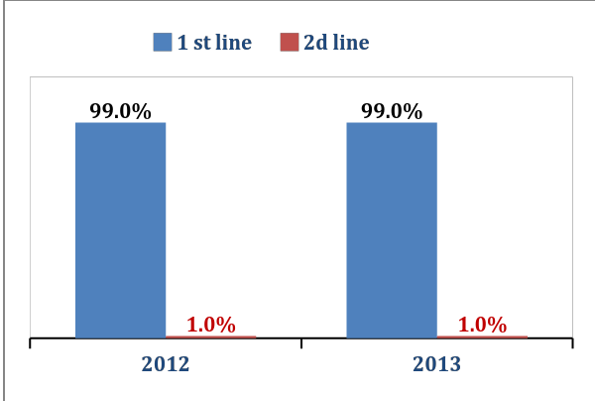 | 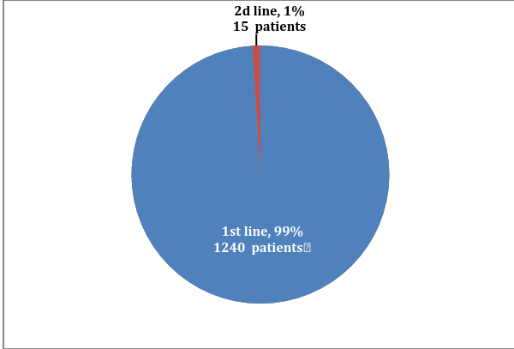
Diagram 1. Patients’ distribution depending on the first and second line ART regimens, % | Diagram 2. Patients’ distribution depending on ART regimens, 2013  (adults who continue receiving ARV therapy, absolute values and %
Adult patients’ distribution depending on ART regimens in 2013 is presented in Diagram 2.
The standard first line ART regimen consists of 2 NRTI and the third component which is 1 NNRTI or enhanced HIV protease inhibitor.
Percentage of different NNRTI (AZT-, TDF- or ABC-containing regimens in combination with 3ТС or FTC) in standard first line regimens depending on the number of adult patients receiving the following regimens at the end of 2013 is presented in Diagram 3. AZT- containing regimens constitute more than 91%, TDF-containing regimens constitute 4.8%, ABC- containing regimens constitute 4.2%.

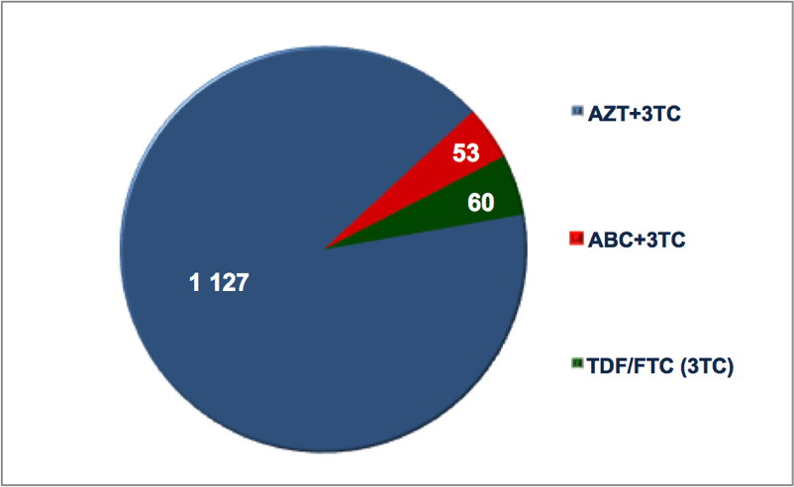 | 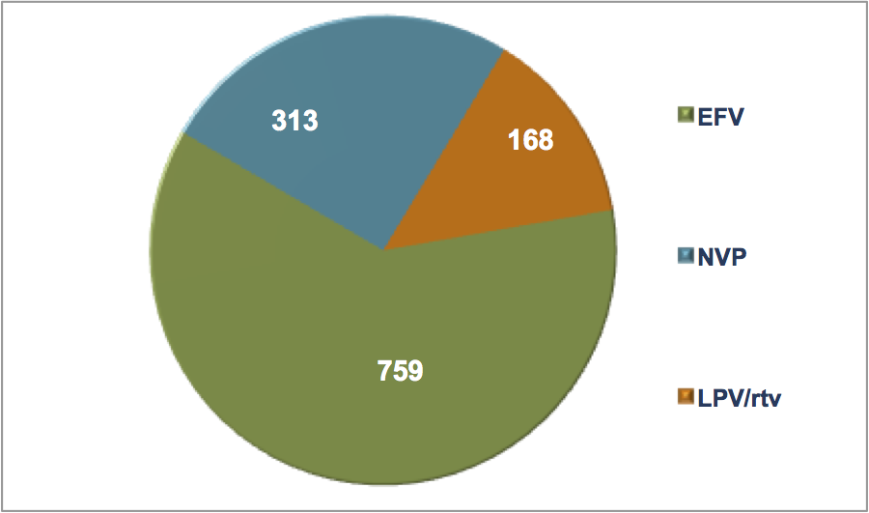
Diagram 3 . Nucleoside basis in the first line ART regimens, 2013  (adults, continue receiving ART) | Diagram 4. Non-nucleoside and HIV protease inhibitor in the first line ART regimens, 2013 (adults, continue receiving ART)

In 2013 percentage of NNRTI in the first line regimens was 86,5%. In 2013 the prevailing NNRTI in the first line regimens prescribed to adult patients was EFV (61% of all the first line ART regimens). ART regimens on the basis of enhanced HIV protease inhibitor (LPV/rtv) were prescribed to 13,5% of patients among those receiving the first line ART regimens in 2013. Percentage of NNRTI and HIV protease inhibitor in the first line ART regimens depending on the number of adult patients receiving the following regimens at the end of 2013 is presented in Diagram 4.
Preference is given to fixed dose combinations: TDF/FTC / EFV, AZT/3TC, TDF/FTC, ABC/3TC, LPV/rtv. The above mentioned antiretroviral drugs are used in fixed dose combinations which in compliance with the existing international evidential basis increases patients’ adherence to treatment, complies with all the international recommendations including WHO approaches.
In 2012–2013 the average cost of the first as well as of the second line ART regimens is presented in Diagram 5 and in 2013 it constituted 153 USD per the first line ART regimen per one patient and 228 USD per the second line ART regimen per one patient.
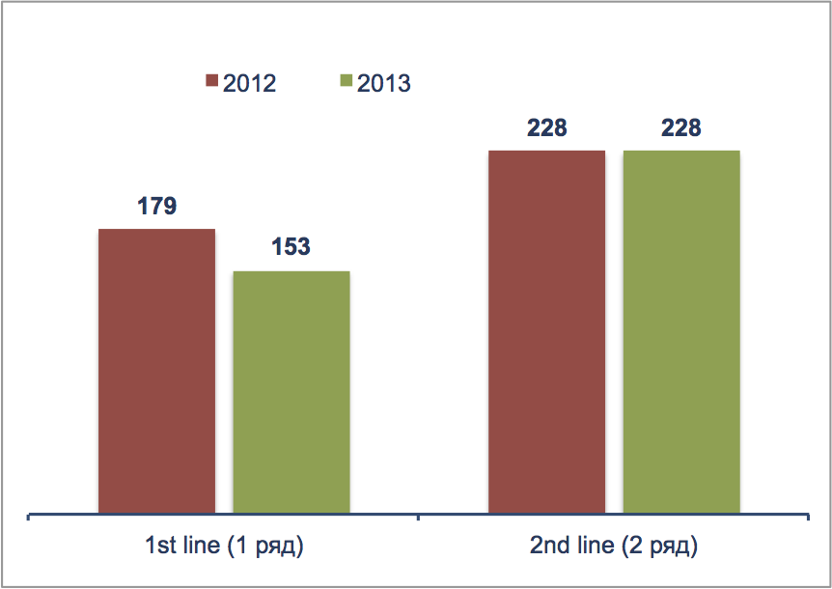

Diagram 5. Patients’ distribution depending on
the first and second line ART regimens, USD

ACCESS TO REGULAR AND QUALITATIVE SERVICES

The number of officially registered PWLH constituted 32,7% from the estimated number of PWLH in the country at the end of 2013.
The percentage of PWLH with the clinical symptoms or the number of CD4 < 350 cells/mcl at the moment of diagnosing HIV infection was 26,7% in 2013. The above mentioned indicator has been growing which might indicate HIV infection in its height. Moreover it also serves as the evidence of late diagnosing HIV infection and consequently causes untimely late ARV therapy initiation as well as expenditures on seriously ill patients.
Simplified technologies of identifying the number of CD4 are unavailable in the process of identifying HIV infection at the level of PWLH in general as well as at the level of PWLH from separate key vulnerable groups at the local, regional and national levels.
Early and systematic access to diagnosing and identifying the number of CD4 for all PWLH is not only one of the essential conditions of ART start on the basis of immunological criterion, but also a factor which influences further indicators of treatment efficiency. As mentioned before, the indicator reflecting the average number of CD4 at the moment of ART start hasn’t been included into the system of monitoring and evaluation.
The indicators of patients’ retention on ART after 12 months of therapy decreased from 74% in 2011–2012 to 67% in 2013. In 2013 The indicator of retention on therapy after 60 months improved in 2013 if compared to 2011, and remained stable at about 58%.
Detailed analysis of number of patients on different regimens noticed some discrepancy between reported data on number of patients receiving ART at the end of the year and data calculated based on the number of patients at each regiment. According to the report of the Republican AIDS Center the number of adults (at the age of 15+) receiving ART at the end of the reporting period is 1 145 people, the number of adults (at the age of 15+) receiving ART regimens at the end of the reporting period is 1 255 people. (+110).
The absence of therapy interruption cases, with at least one patient’s interruption lasting more than a week in a year, might indicate the thorough monitoring of antiretroviral drugs according to ART regimens, the number of patients receiving separate ART regimens and their components, the effective work of monitoring and supply chain, its connection to the system of biofeedback which in its turn allows to provide regular ARV therapy for all patients who received access to treatment.
At the same time, monitoring and reporting of treatment interruption due to the stock-out issues need to be analyzed more in-depth.
TABLE 4. INDICATORS OF ART CONTINUITY AND EFFECTIVENESS
 | 2011 | 2012 | 2013
Percentage of PWLH continuing receiving ART after 12 months, % | 73.4 | 74 | 67
Percentage of PWLH continuing receiving ART after 60 months, % | 33.8 | 56.8 | 57.8
The number of stock-outs which would happen to at least 1 patient and last more than a week in the course of a year | 0 | 0 | 0
The number of patients on ART checking their viral load at least once a year | n/d | 137 | 650
The number of patients with the unidentified viral load among those continuing ART | nd | 122 | 481

The current National Clinical Protocols approved by the Ministry of Health prescribe systematic monitoring of the viral load (VL) for all HIV infected patients on ART at intervals of once per 6 months to prove virological efficiency of the therapy and patients’ adherence to treatment.
The indicator of VL which is equal to 50 copies RNA HIV/ml of plasma serves as the threshold of sensitivity to the used test systems in the country. In case when VL is < 50 copies RNA HIV/ml of plasma it’s “unidentified”.
Viral load testing is available only at one health care institution providing ARV therapy and is tested not less than once in a year for patients receiving ART. The percentage of patients with unidentified viral load among those on treatment is 42% (481 out of 1145).

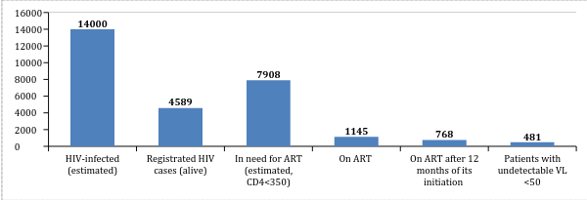

Diagram 6. PWLH access to regular effective health care services (2013)

FUNDING OF HIV/AIDS PROGRAMS

There was a decrease in funding programs to fight HIV infection in the years 2011–2013. In 2011 the overall annual expenditures to fight HIV epidemic were 7,5 mln USD, in 2012 they were 6,4 mln. USD and in 2013 this sum reached only 7.1 mln. USD. In most cases these are the funds of international donors. Percentage of government funding from the overall annual budget to fight HIV/AIDS epidemic increased from 14,7% in 2011 up to 23,9% in 2013.
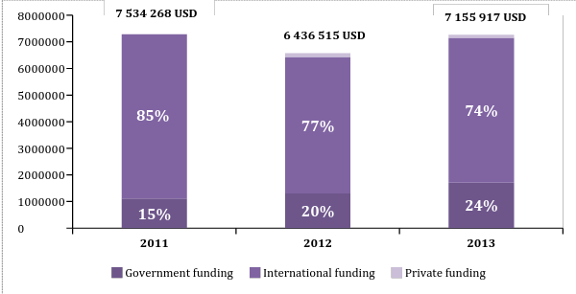
Diagram 7. The overall annual expenditures to fight
HIV epidemic, USD and %

In 2011 percentage of funding of the treatment and support programs for patients on ARV therapy against the overall annual budget to fight HIV epidemic constituted 8,5%, while in 2013 it increased up to 10,1%.
Percentage of the government funding to provide ARV therapy increased from 38% in 2011 up to 51% in 2013. However, it should be kept in mind that the above mentioned funds don’t include procurement. There wasn’t any government funding of ART in the country before 2013 and ART procurement was realized only due to funds of international donors, and to be exact - mainly due to funding of the Global Fund to fight HAIDS, tuberculosis and malaria.
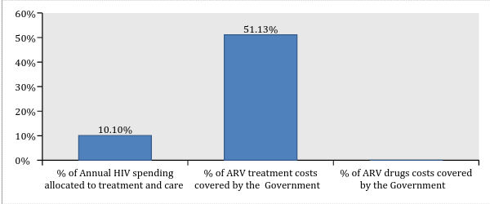

Diagram 8. Funding of treatment and support programs, 2013, %

CONCLUSIONS
The range of some indicators including the indicators of HIV prevalence and spread imply stabilization of the epidemic process among general population as well as among the risk groups in the Republic of Tajikistan. The number of officially registered PWLH is 32.7% from the estimated number of PWLH in the country. Therefore, two thirds of all the cases of HIV infection remain unidentified.
The Republic of Tajikistan can be characterized by the epidemic in its full swing and the government will have to take strenuous efforts to provide the universal access to treatment.
According to sentinel surveillance data active epidemic process is concentrated in vulnerable groups and high indicators of HIV prevalence have been demonstrated among PWID, CSW, MSM. However, the system of HIV infection routine monitoring doesn’t allow the thorough monitoring and analysis of all the indicators among the above mentioned groups. Because of routine monitoring limitations it’s difficult to evaluate ART coverage among vulnerable groups. The existing data on the treatment coverage of PWID are insufficient.
ART coverage has been constantly growing which resulted in improvement of indicators of AIDS prevalence and AIDS mortality. Though taking a high number of unidentified PWLH and late cases of HIV infection diagnosing into consideration, indicators of the universal access to treatment are insufficient for treatment to perform prevention function.
In 2013 ART procurement was realized due to the funds of the Global Fund to fight AIDS, tuberculosis and malaria. Introduction of treatment covered by the funds of the government would need considerable expenditures from the central and local budgets to fight the epidemic in the nearest future.
In 2013 percentage of adult patients receiving the first line ART regimens constituted 99% from all adult PWLH receiving ARV therapy.
By the latest data available all patients receive standard ART regimens. In 2013 percentage of the first line ART regimens based on NNRTI was 86.5%. In 2013 the prevailing NNRTI in the first line ART regimen prescribed to adult patients was EFV (61%) while more than 25% of patients on the first line ART regimens received ART regimens based on NNRTI-NVP. ARV therapy is prescribed in the form of fixed dose combinations including three component regimens of the first line based on NNRTI which in its turn is in compliance with the existing international evidential database increases patients’ adherence to treatment and complies with all the international recommendations including WHO approaches.
The number of reported patients continuing receiving AVT doesn’t coincide with the number of ARV drugs and ARV components in ART regimens. However, the absence of cases of treatment interruption indicates that monitoring of antiretroviral drugs is functional.
The data collecting system as routine surveillance of epidemic and treatment indicators is developed enough though it has some restrictions in terms of data related to the most vulnerable groups. Some indicators of treatment efficiency are not included into the reporting system though this information allows doing it.
Quantitative data analysis of annually registered cases of HIV, AIDS and AIDS related deaths is essential in the process of general assessment of the epidemic situation with HIV infection. While collecting and analyzing data provided by the surveillance it’s important to implement some tool which will allow their disaggregation for identifying the structure and data analysis of newly registered cases of HIV infection, disease incidents, death via their clinical epidemiological indicators including key epidemiological indicators, such as belonging to particular vulnerable groups and clinical epidemiological indicators: stage of HIV infection and level of CD4 at the moment of diagnosing the case, data on the structure of AIDS defining illnesses, causes of death of PWLH: related to HIV, not related to HIV, because of AIDS defining illnesses or some other diseases/conditions which served as the cause for death and when cause of death remains undetermined.
Available clinical epidemiological characteristics of key epidemiological data on disease prevalence and death cases among PWLH are important for development and assessment of effective measures to respond the epidemic.

RECOMMENDATIONS
HIV Testing Accessibility
- The system of HIV testing monitoring should include not only tests volume but also the structure of these tests (by gender and age).
- It’s necessary to increase percentage of HIV tests carried out among risk groups and their intercourse partners, improve access to tests among key vulnerable groups, identify effective “entry points” of access to counseling and testing which gives the opportunity to shorten the difference between estimated and registered number of PWLH.
- It’s important to introduce/implement data collection and analysis reflecting connection of the number of HIV tests in separate groups with the number of newly registered PWLH from these groups and with those who received access to CD4 analysis and other services of treatment, care and support including ART for the reporting period. The following approach gives the opportunity to receive and evaluate information about HIV testing efficiency.
Epidemiological monitoring and biofeedback.
- It’s highly recommended to collect data on HIV tests, the number of newly registered cases of HIV infection, AIDS, mortality of PWLH and AIDS mortality applying methods and tools allowing to identify the structure of the following data as well as to conduct analysis on the basis of clinical epidemiological characteristics including key epidemiological indicators (belonging to particular vulnerable to HIV infection groups among them), as well as clinical epidemiological indicators such as HIV infection stage and the number of CD4 at the moment of diagnosing HIV infection, HIV infection stage and the number of CD4 at the moment of ART start, access to ARV therapy (if there has been a new case of AIDS defining disease or death in the course of receiving ART or while being out of this access), ART duration.
- To introduce data collection and coverage evaluation of CD4 among general population of PWLH and PWLH who are representatives of key vulnerable groups while diagnosing HIV infection and in the course of follow-up.
- To introduce data monitoring and analysis on the structure of AIDS defining diseases.
- To conduct data collection which allows their disaggregation and analysis on the reasons of PWLH deaths: cases related to HIV infection, those which are not related to HIV, because of AIDS defining diseases or some other diseases/conditions which served the cause of death, as well as deaths of PWLH when the cause has been unidentified.
- It’s necessary to implement methodology of triangulation data analysis (recommended by UNAIDS/WHO, 2013) in order to prove the main tendencies of the epidemic process of HIV infection. The above mentioned methodology implies collection and analysis of quantitative and qualitative data received from several sources using different methods of information collection which gives the opportunity to receive more reliable data of evaluation of the epidemic situation with HIV infection among general population as well as among different social and vulnerable to HIV infection groups.
ART Accessibility
- It’s necessary to scale up access to treatment programs for PWLH supported by both the government funds and the funds of international donors.
- It’s necessary to provide early access of newly registered PWLH to diagnosing the number of CD4 cells - possibly with the use of simplified technologies of rapid identification of CD4 number.
- To approximate substitution therapy to ARV therapy for those PWID in need of integrated services.
- To consider possibility of opening sites of integrated services for PWLH/PWID at health care institutions providing treatment to PWLH.
- To provide access to systematic routine survey of CD4 number and viral load for all PWLH from the dispensary group at intervals approved by the National Clinical Protocol.
- To introduce monitoring and analysis of CD4 mid level at the moment of ART start at the health care institutions providing services to PWLH at the local, regional and national levels which would allow precise evaluation of timely access to ART.
- To improve the systems of clinical monitoring of all patients receiving ART and, specifically, of timely record of patients dropped out of the treatment program with the analysis of the dropout’s reasons/causes (patient’s death, ART interruption for some other reasons, causes identification and analysis). It will allow a more precise identification of the number of patients receiving ART in the course of some separate period (e.g. 12 months, 24 months, 60 months), based on the cohorts’ analysis.
- To improve relation of the system of clinical monitoring to procurement and supply chain based on the importance of providing regular ART for those patients who have already received access to treatment within those regimens they receive and there are no signs of inefficiency or intolerance.
- To improve planning systems of access to ART scale up and relation of planning to procurement and supply chain based on the importance of access to ART for those patients who need it in compliance with the current National Clinical Protocol.
- To introduce monitoring of indicators of early prevention of antiretroviral resistance in compliance with WHO recommendations at health care institutions at the local, regional and national levels:
  - ART prescription
  - Patients lost/dropped out of the follow up during the first 12 months (absolute number and %);
  - Patients continuing receiving the first line ART regimen after 12 months of treatment;
  - Following schedule of attending health care institutions to receive ART;
  - Timely receipt of ART;
  - Regular procurement of ARV drugs.
- To improve the system of complex (medico-social) approach to PWLH treatment (help patients realize the importance of systematic check-up, existence of effective record system of attending health care institutions, sufficient level of case management and support (oriented at the individual patient’s needs) of HIV infected patients, support of patients’ adherence to treatment) aimed at forming a higher level of adherence to ART.
- Improvement in case management based on multidisciplinary approach involving clinical structures and PWLH communities when regular support is provided.

ABBREVIATIONS

ARV – antiretroviral, ART – antiretroviral therapy, CSW – commercial sex workers, MSM – men who have sex with men, GF – Global Fund, n/d – no data available, PWID – people who inject drugs, PWLH – people living with HIV, TB – tuberculosis, VCT - voluntary counseling and testing, VL – viral load.

ACKNOWLEDGMENTS

Research team is grateful to Zuhra Nurlyaminova and Alijon Soliev, the representatives of AIDS centre in Tajikistan, for their assistance in data collection and participation in the review of this document.

