Antiretroviral therapy. THE REPUBLIC OF KYRGYZSTAN

EPIDEMIOLOGICAL CONTEXT

HIV/AIDS Incidence and Prevalence and AIDS Mortality.
The estimated number of PWLH in the Republic of Kyrgyzstan was 8021 in 2013. The indicators of HIV infection imply stabilization of the epidemiological process among general population as well as among such key vulnerable groups as PWID and CSW in the Republic of Kyrgyzstan. Meanwhile the HIV prevalence among MSM has increased and these data indicate unstable epidemiological situation in this particular group (Table 1).
TABLE 1. MAIN EPIDEMIOLOGICAL INDICATORS
 | 2011 | 2013
The estimated number of PWLH | 7027 | 8021
HIV prevalence among adults (at the age of 15–49 years old), % | 0.22 | 0.24
HIV spread among PWID according to sentinal surveillance data, % | 14.6 | 12.4
HIV prevalence among MSM according to sentinal surveillance data, % | 1.1 | 6.3
HIV prevalence among CSW according to sentinal surveillance data, % | 3.5 | 2.2
The number of newly registered cases of HIV infection | 599 | 504
HIV incidence per 100 000 people | 10.8 | 8.8
Percentage of officially registered PWLH from the estimated number, % | 20.5 | 26.6
AIDS case rate per 100 000 people | 1.7 | 1.2
AIDS related death, per 100 000 people | 2.1 | 3.0

In 2013 the number of officially registered PWLH was 26.6% from the estimated number of PWLH in the country.
As a result of low ART coverage, AIDS related mortality is still growing. At the same time, the number of new AIDS cases and AIDS rate is decreasing.

HIV TESTING ACCESSIBILITY/AVAILABILITY

The overall number of HIV tests was 444 661 which meant that there were 7 773 tests per 100 000 people in 2013 (Table 2). Routine surveillance data on testing reflect their intensity and expenditures though these data don’t reflect tests structure (by gender and age)

TABLE 2. HIV TESTING INDICATORS
 | 2011 | 2013
The overall number of HIV tests per 100 000 people | 7 601 | 7 773
The number of HIV tests among key vulnerable groups
PWID | 5297 |  | 4256
МSМ | 79 |  | 396
CSW | 292 |  | 1597
migrants | 13 025 |  | 8 832
% of pregnant women tested for HIV over the last 12 months and aware of their results | 72 |  | 938
% of patients with TB aware of their HIV positive status | 100 |  | 100 (2012)

Tests coverage among risk groups fluctuates. There is the decrease in HIV testing among PWID and migrants. At the same time the number of CSW tested on HIV over the last few years increased five times. Notwithstanding the increase in the volume/number of tests among CSW and MSM the share of risk groups in the structure of testing remains low and for instance in 2013 it constituted only 3.4%.
The indicator of tests coverage among pregnant women considerably improved and in 2013 it was 93,8%.
Tests coverage among patients with TB aware of their results remains at the level of 100%.

ACCESS TO ART

In the Republic of Kyrgyzstan there are 67 health care institutions providing ART. All the above mentioned health care institutions providing treatment to PWLH diagnose tuberculosis. In 2013 the share of HIV infected people in the result of injecting drugs among adult PWLH who had received access to ART was 45.1%. There are no data available on other key vulnerable groups with the access to ARV therapy.
In the Republic of Kyrgyzstan there is no monitoring of the number of PWID who receive ART and substitution therapy at the same time. It’s important to note that the number of patients receiving substitution therapy exceeds the number of patients on ART: at the end of 2013 779 patients received ART while substitution therapy was prescribed to 1100 patients (Annex: Table of indicators).
Substitution therapy was provided in two sites. There is only one health care institution in the country providing integrated services for PWLH/PWID where patients can receive not only ART but also substitution therapy. This is due to the absence of qualified specialists trained in provision of substitution therapy excluding narcologists. There is no such opportunity as to provide ART to HIV infected patients also needing substitution therapy in addiction clinics while substitution therapy is not provided in health care institutions different from addiction clinics.
Improving the access to ART (from 341 to 779) among adult PWLH was observed in 2011–2013. The total ART coverage was 9.7% from the estimated number of PWLH in the country in 2013 and demonstrated a tendency to increase (in comparison with 4.9% in 2011). In 2013 году 779 PWLH out of 2138 adult patients of the dispensary group, 36.4 % of those PWLH who had visited health care institution at least once in the reported year received ARV therapy (Table 3).
TABLE 3. ACCESS TO ARV THERAPY AND MEDICAL FOLLOW UP

 | 2011 | 2012 | 2013
The number of adults (at the age of 15+) receiving ARV therapy at the end of the year | 341 | 469 | 779
Percentage of adults (at the age of 15+) receiving ARV therapy from the estimated number of PWLH,% | 4.9 | 5.4 | 9.7
Adults’ percentage (at the age of 15+) receiving ARV therapy from the number of the dispensary group, % | 197 | 21.8 | 36.4
The number of PWID receiving ART | n/d | n/d | 351
The number of representatives from other key vulnerable groups receiving ART | No data available
Percentage of PWID among adults (at the age of 15+) receiving ARV therapy, % | n/d | n/d | 45.1
Percentage of representatives from other key vulnerable groups receiving ART | No data available
The number of HIV infected PWID receiving ARV and substitution therapy | n/d | n/d | n/d
Percentage of PWLH tested for CD4 level at the moment of diagnosing the case (in the course of 2 months after diagnosing the case), % | n/d | 35.2* | 44.8*
Percentage of PWLH with the clinical symptoms and CD4 < 350 at the moment of diagnosing the case | No data available
The average number of patients’ CD4 at the moment of ART start* | No data available
* The following data are not properly monitored. Pilot project on implementing the electronic recording system to monitor cases of HIV infection has been implemented in the Republic of Kyrgyzstan. In future the above mentioned system is planned for monitoring the following indicator.
The current National Clinical Protocols approved by the Ministry of Health prescribe systematic monitoring of the level of CD4 for all HIV patients which helps to solve the issues related to the start of ARV therapy as well as opportunistic infections prevention.
In compliance with the National Protocol the immunological threshold for starting ARV therapy was the level of CD4 < 350 cells/mcl in 2013.
Data on PWLH with the clinical symptoms or the number of CD4 <350 cells/mcl at the moment of diagnosing HIV infection are not the subject to monitoring though the electronic recording system to monitor the cases of HIV infection has been developed at the moment and is planned to be implemented in the nearest future. Simplified technologies of identifying the level of CD4 are unavailable as at the level of diagnosing HIV infection so at the level of population of PWLH, PWLH from separate key vulnerable groups at the local, regional and national levels. In some health care institutions providing services to PWLH there is CD4 analysis before ART start which performs the function of the routine survey. However it should be noted that the indicator of CD4 at the moment of diagnosing HIV infection, in the process of medical check-up, at the moment of ART start at the level of PWLH as well as at the level of health care institutions (locally, regionally and nationally) wasn’t included into the system of monitoring and evaluation.
Therefore the current system of biofeedback at the level of health care institutions providing services to PWLH at the local, regional and national levels doesn’t provide the opportunity for getting timely data on patients’ distribution on the number of their CD4 at the moment of ARV therapy start, for identifying the median/midpoint of the number of CD4 at the moment of ART start at the local, regional, national levels and at the level of particular health care institutions.

ART AND PROCUREMENT SERVICES

ARV therapy is provided as to “naive” as well as to experienced patients in compliance with the current National Clinical Protocol approved by the Ministry of Health.
In compliance with the National Clinical Protocol the first line ART regimens include ART regimens prescribed to “naïve” patients for the very first time in their lives as well as “substitution” regimens when separate components of initially prescribed regimen are substituted as the result of toxicity/intolerance to some ARV drugs. All patients on the first line ART regimens receive standard three component regimens.
The second line ART regimens are those prescribed in case of failure in use of the first line SRVT regimens when the first line ARV regimen is substituted by the second line ART regimen. Failure in ART” means existence of some virological, immunological and clinical symptoms of treatment failure. The described approach complies with the recommendations of WHO.
In the last few years percentage of adult patients receiving the first line ART regimens constituted 98.5% from all adult patients among PWLH receiving ARV therapy.

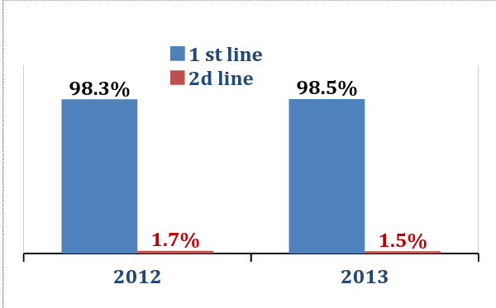 | 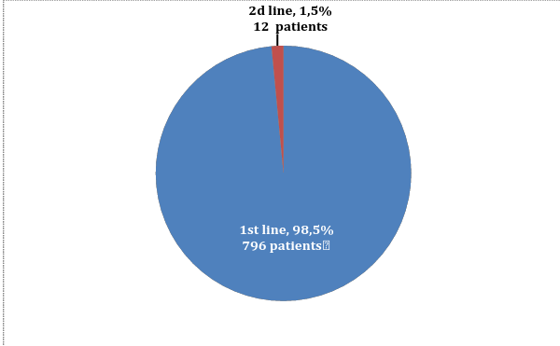
Diagram 1. Patients’ distribution depending on the first and second line ART regimens, % | Diagram 2. Patients’ distribution depending on ART regimens, 2013  (adults, who continue receiving ARV therapy, absolute values and %)
Adult patients’ distribution depending on ART regimens in 2013 is presented in Diagram 2.
The standard first line ART regimen consists of 2 NRTI and the third component which is 1 NNRTI or HIV protease inhibitor.
Percentage of different NRTI (AZT-, TDF- and ABC-containing in combination with 3ТС or FTC) in standard first line regimens depending on the number of adult patients receiving the following regimens at the end of 2013 is presented in Diagram 3. AZT- containing regimens constitute 65%, TDF-containing regimens constituted 26,2% and ABC-containing regimen constitute up to 3,1%. 3 NRTI regimen (which is presented in Diagram 3 in combination of AZT+ABC, AZT+ TDF, ABC + TDF when the third component of the regimen is 3TC) was prescribed to 43 adult patients and 796 patients receiving the first line ART regimen in 2013.
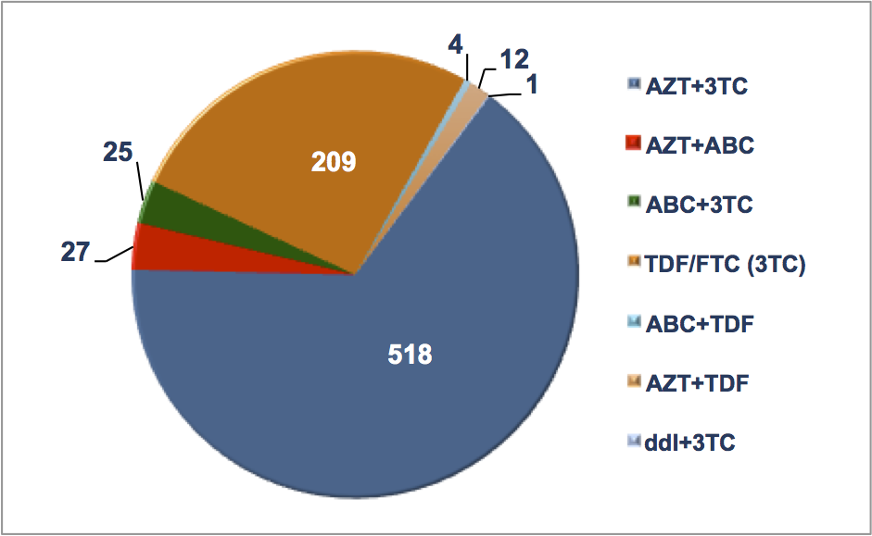 | 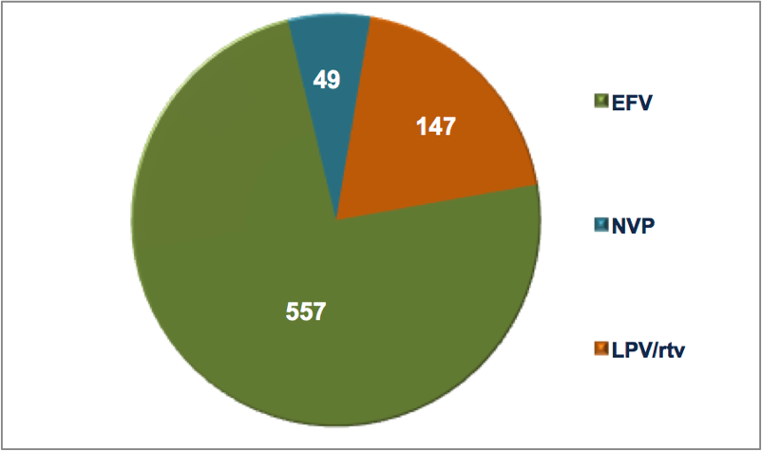
Diagram 3. Nucleoside basis in the first line ART regimens, 2013 (adults, continue receiving ART) | Diagram 4. Non-nucleoside  in the first line ART regimens, 2013 (adults, continue receiving ART)

The percentage of NNRTI in the first line regimens was 76.1% in 2013. The prevailing NNRTI in the first line regimens prescribed to adult patients was EFV in 2013 (70% of all the first line ART regimens). ART regimens on the basis of enhanced HIV protease inhibitor (LPV/rtv) were prescribed to 18.5% of patients receiving the first line ART regimens in 2013. The share of NNRTI and HIV protease inhibitor in the first line ART regimens depending on the number of adult patients at the end of 2013 is presented in Diagram 4.
Preference is given to fixed dose combinations: AZT/3TC, TDF/FTC, ABC/3TC, LPV/rtv. The above mentioned antiretroviral drugs are used in fixed dose combinations which in compliance with the existing international evidential basis increases patients’ adherence to treatment, complies with all the international recommendations including WHO approaches.
The average cost of the first as well as of the second line ART regimens in 2012–2013 is presented in Diagram 5 and in 2013 it constituted 198 USD per the first line ART regimen per one patient per year and 620 USD per the second line ART regimen per one patient per year.
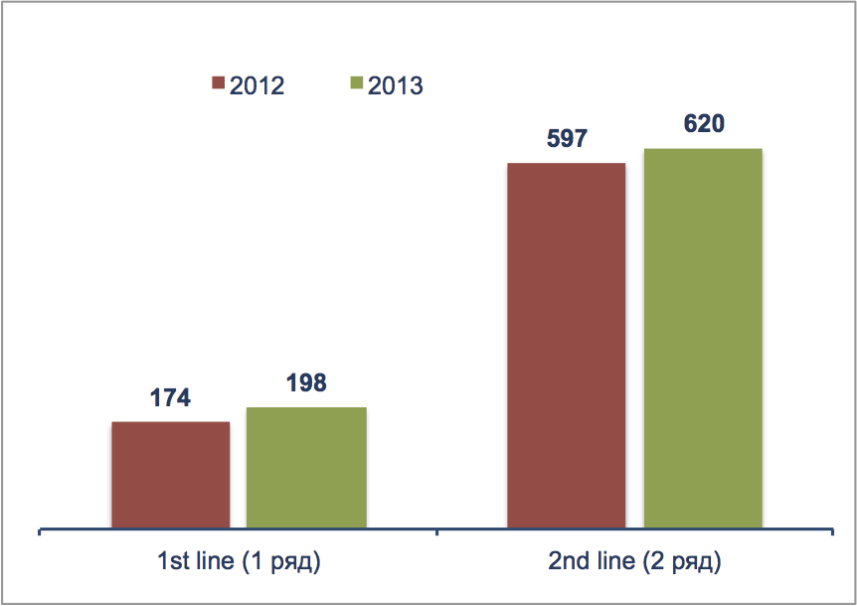
Diagram 5. The average cost of the first and second line ART regimens
per one patient per year, USD

ACCESS TO REGULAR AND QUALITATIVE SERVICES
The number of officially registered PWLH was 20% in 2011 and in 2013 it was 26.6% from the estimated number of PWLH in the country.
There are no data available on PWLH with the clinical symptoms or the number of CD4 < 350 cells/mcl at the moment of diagnosing HIV infection which can’t serve the evidence of late (early) diagnosing HIV infection and consequently of untimely (early) ARV therapy.
Simplified technologies of identifying the number of CD4 are unavailable in the process of identifying HIV infection at the level of PWLH in general as well as at the level of PWLH from separate key vulnerable groups at the local, regional and national levels.
Early and systematic access to diagnosing and identifying the number of CD4 for all PWLH is not only one of essential conditions of ART start on the basis of immunological criterion but also factor which influences further indicators of treatment efficiency. As mentioned before the indicator reflecting the average number of CD4 at the moment of ART start hasn’t been included into the system of monitoring and evaluation.
The indicators of patients’ retention on ART remain stable: 82.6% of patients continue ART after 12 months of therapy. The indicator of retention on therapy after 60 months improved and constituted 61% in 2013
Detailed analysis of number of patients on different regimens noticed some discrepancy between reported data on number of patients receiving ART at the end of the year and data calculated based on the number of patients at each regimen. According to the report of the Republican AIDS Center the number of adults (at the age of 15+) receiving ART at the end of the reporting period is 779 people, the number of adults (at the age of 15+) receiving ART regimens at the end of the reporting period on regimens is 808 people (+29).
The absence of cases of therapy interrupting with at least one patient lasting more than a week in a year might suggest thorough monitoring of antiretroviral drugs according to ART regimens, the number of patients receiving separate ART regimens and their components, the effective work of monitoring and supply chain, its connection to the system of biofeedback which in its turn allows to provide regular ARV therapy for all patients who received access to treatment.
The same time, monitoring and reporting of treatment interruption due to the stock-out issues need to be analyzed more in-depth.

TABLE 4. INDICATORS OF ART CONTINUITY AND EFFECTIVENESS

 | 2011 | 2012 | 2013
Percentage of PWLH continuing receiving ART after 12 months, % | 88.2 | 73 | 82.6
Percentage of PWLH continuing receiving ART after 60 months | 17.3 | 49 | 61
The number of stock-outs which would happen to at least 1 patient and last more than a week in the course of a year | 0 | 0 | 0
The number of patients on ART checking their viral load at least once a year | n/d | n/d | 476
The number of patients with the unidentified viral load. |  |  | 275

The current National Clinical Protocols approved by the Ministry of Health prescribe systematic monitoring of the viral load (VL) for all HIV infected patients on ART at intervals of once per 6 months to prove virological efficiency of therapy and patients’ adherence to treatment.
The indicator of VL which is equal to 50 copies RNA HIV/ml of plasma serves the threshold of sensitivity to the used test systems in the country. In case when VL is < 50 copies RNA HIV/ml of plasma it’s “unidentified”.
Viral load testing is available only at health care institutions providing ARV therapy and is tested not less than once a year for patients receiving ART. The percentage of patients with unidentified viral load among those on treatment is 35% (275 out of 779).

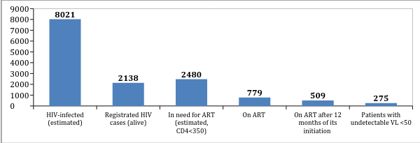

Diagram 6. PWLH access to regular effective health care services (2013)

FUNDING OF HIV/AIDS PROGRAMS

In absolute values 2011–2013 were characterized by a considerable increase in funding programs to fight HIV infection. The share of funds from international donors constitutes approximately 3/4 from the overall annually allocated budget in comparison with 2011.
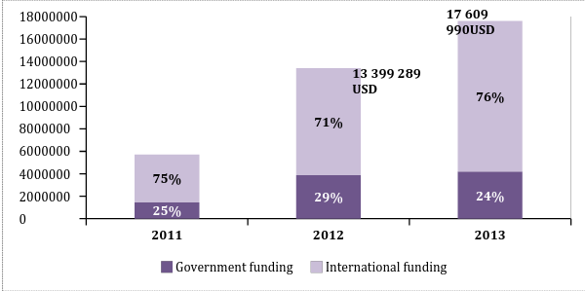
5 720 875 USD

Diagram 7. The overall annual expenditures to fight
HIV epidemic, USD and %

12% of the overall budget allocated to fight the epidemic of HIV infection was used to fund the programs of PWLH treatment and support in 2013. Before 2012 ART procurement was fully realized on the funds of the Global Fund to fight AIDS, tuberculosis and malaria.

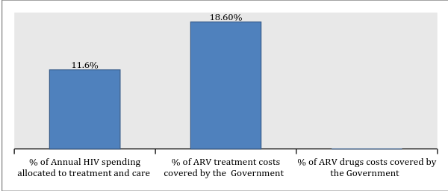
Diagram 8. Funding of treatment and support programs, %

CONCLUSIONS
The range of indicators of HIV prevalence and spread imply stabilization of the epidemic process as among general population so among some risk groups (PWID and CSW) in the Republic of Kazakhstan. The number of officially registered PWLH is 26.6% from the estimated number of PWLH in the country. Therefore it means that every fourth case of HIV infection acquires the status of being unidentified.
The system of HIV infection routine monitoring doesn’t allow thorough monitoring and analysis of all the indicators among the above mentioned groups. Because of routine monitoring limitations it’s difficult to evaluate ART coverage among vulnerable groups (excluding PWID).
ART coverage has been constantly growing, although it is still low to impact the AIDS related deaths. Moreover, taking into account a high numbers of unidentified cases indicators of the universal access to treatment are insufficient for treatment to perform prevention function.
ART procurement was realized on the funds of the Global Fund to fight AIDS, tuberculosis and malaria in 2013. In order to provide treatment on the government funds in the nearest future the country will have to considerably increase its expenditures to fight the epidemic as well as to increase funds from the central and local budgets.
The share of adult patients receiving the first line ART regimens was 98.3% from all adult PWLH receiving ART in 2012 and in 2013 this number was 98.5%. All patients are prescribed standard regimens.
In 2013 percentage of the first line ART regimens based on NNRTI was 76.1%. In 2013 the prevailing NNRTI in the first line ART regimen prescribed to adult patients was EFV (70%) while more than 25% of patients on the first line ART regimens received ART regimens based on NNRTI-NVP. ARV therapy is prescribed in the form of fixed dose combinations including three component regimens of the first line based on NNRTI which in its turn in compliance with the existing international evidential database increases patients’ adherence to treatment and complies with all the international recommendations including WHO approaches.
The number of reported patients continuing receiving AVT doesn’t coincide with the number of ARV drugs and ARV components in ART regimens. However, in the Republic of Kyrgyzstan there weren’t any cases of treatment interruption which would happen to at least one of patients and last more than a week in the course of a year.
Quantitative data analysis of annually registered cases of HIV, AIDS and AIDS related deaths are essential in the process of general assessment of the epidemic situation with HIV infection. While collecting and analyzing data provided by the surveillance it’s important to implement some tool which will allow their disaggregation for identifying the structure and data analysis of newly registered cases of HIV infection, disease incidents, deaths related their clinical epidemiological indicators including key epidemiological indicators, such as belonging to particular vulnerable groups and clinical epidemiological indicators: stage of HIV infection and level of CD4 at the moment of diagnosing the case, data on the structure of AIDS defining illnesses, mortality rate of PWLH: related to HIV, not related to HIV, because of AIDS defining illnesses or some other diseases/conditions which served the mortality rate and when cause of deaths remains undetermined.
Available clinical epidemiological characteristics of key epidemiological data on disease prevalence and mortality rate among PWLH are important for development and assessment of effective measures to respond the epidemic.

RECOMMENDATIONS

HIV Testing Accessibility
- The system of HIV testing monitoring should include not only tests volume but also the structure of these tests (by gender and age). Monitoring of tests structure among vulnerable groups needs improvement.
- It’s necessary to increase share of HIV tests carried out among risk groups and their intercourse partners, improve access to tests among key vulnerable groups, identify effective “entry points” of access to counseling and testing which gives the opportunity to shorten the difference between estimated and registered number of PWLH.
- It’s important to introduce/implement data collection and analysis reflecting connection of the number of HIV tests in separate groups with the number of newly registered PWLH from these groups and with those who received access to CD4 analysis and other services of treatment, care and support including ART for the reporting period. The following approach gives the opportunity to receive and evaluate information about HIV testing efficincy.

Epidemiological and Clinical Monitoring
- It’s highly recommended to collect data on HIV tests, the number of newly registered cases of HIV infection, AIDS, mortality of PWLH and AIDS related deaths (annually or for some other reporting period) applying methods and tools allowing to identify the structure of the following data as well as to conduct analysis on the basis of clinical epidemiological characteristics including key epidemiological indicators, among them are belonging to particular vulnerable to HIV infection groups as well as clinical epidemiological indicators such as HIV infection stage and the number of CD4 at the moment of diagnosing HIV infection, HIV infection stage and the number of CD4 at the moment of ART start, access to ARV therapy (if there has been a new case of AIDS defining disease or mortality rate in the course of receiving ART or while being out of this access), ART duration.
- To introduce data collection and coverage evaluation of CD4 among general population of PWLH and PWLH who are representatives of key vulnerable groups while diagnosing HIV infection and in the course of follow-up.
- To introduce data monitoring and analysis on the structure of AIDs defining diseases.
- To conduct data collection which allows their disaggregation and analysis on the reasons of PWLH deaths: those cases related to HIV infection, those which are not related to HIV, because of AIDS defining diseases or some other diseases/conditions which served the mortality rate, as well as deaths of PWLH when the cause has been unidentified.
- It’s necessary to implement methodology of triangulation data analysis (recommended by UNAIDS/WHO, 2013) in order to prove the main tendencies of the epidemic process of HIV infection. The above mentioned methodology implies collection and analysis of quantitative and qualitative data received from several sources using different methods of information collection which gives the opportunity to receive more reliable data of evaluation of the epidemic situation with HIV infection as among general population so among different social and vulnerable to HIV infection groups.

ART Accessibility
- It’s necessary to improve access to treatment programs for PWLH supported by both the Government funds and the funds of international donors.
- To provide early access of newly registered PWLH to diagnosing the number of CD4 cells possibly with the use of simplified technologies of rapid identification of CD4 number.
- To approximate substitution therapy to ARV therapy for those PWID in need of integrated services by increasing the number of sites of integrated services for PWLH/PWID at health care institutions providing treatment to PWLH.
- To provide access to systematic routine survey of CD4 number for all PWLH from the dispensary group at intervals approved by the National Clinical Protocol.
- To introduce monitoring and analysis of CD4 mid level at the moment of ART start at health care institutions providing services to PWLH at the local, regional and national levels which would allow precise evaluation of timely access to ART.
- To improve the systems of clinical monitoring of all patients receiving ART and, especially, of timely record of patients dropped out of the treatment program with the analysis of the dropout’s reasons/causes (patient’s deaths, ART interruption for some other reasons, causes identification and analysis). It will allow a more precise identification of the number of patients receiving ART in the course of some separate period (e.g. 12 months, 24 months, 60 months), based on the cohorts’ analysis.
- To improve relation of the system of biofeedback to procurement and supply chain based on the importance of accesses of ART for those patients who have already received access to treatment within those regimens they receive and there are no signs of inefficiency or intolerance.
- To improve planning systems of access to ART scale up and relation of planning to procurement and supply chain based on the importance to provide access to ART to those patients who need it in compliance with the current National Clinical Protocol.
- To introduce monitoring of indicators of early prevention of antiretroviral resistance in compliance with WHO recommendations at health care institutions at the local, regional and national levels:
        - ART prescription
        - Patients lost/dropped out of the follow up during the first 12 months (absolute number and %);
        - Patients continuing receiving the first line ART regimen after 12 months of treatment;
        - Following schedule of attending health care institutions to receive ART;
        - Timely receipt of ART;
        - Regular procurement and uninterrupted supply of ARV drugs.
- To improve the system of complex (medico-social) approach to PWLH treatment (help patients realize the importance of systematic check-up, existence of effective record system of attending health care institutions, sufficient level of case management and support (oriented on individual patient’s needs) of HIV infected patients, support of patients’ adherence to treatment) aiming at forming a higher level of adherence to ART.

ABBREVIATIONS

ARV – antiretroviral, ART – antiretroviral therapy, CSW – commercial sex workers, MSM – men who have sex with men, GF – Global Fund, n/d – no data available, PWID – people who inject drugs, PWLH – people living with HIV, TB – tuberculosis, VL – viral load.

ACKNOWLEDGMENTS

Research team is grateful to Talgat Mambetov, the representative of AIDS centre in the Republic of Kyrgyzstan for his assistance in data collection and participation in the review of this document.

