Antiretroviral therapy. THE REPUBLIC OF ARMENIA

EPIDEMIOLOGICAL CONTEXT
HIV/AIDS Incidence and Prevalence and AIDS Mortality.
Over a period of 1988–2013 in the Republic of Armenia there were 1619 registered cases of HIV infection (cumulative data). The estimated number of PWLH in the Republic of Armenia constituted 3700 in 2013. There was a growth in the number of newly registered cases of HIV infection: in 2011 there were 182 newly registered cases of HIV infection, in 2012 and 2013 there were 228 and 238 cases correspondingly. The indicators of HIV infection spread imply stabilization of the epidemiological process among key vulnerable groups such as PWID, MSM and CSW in the Republic of Armenia (Table 1).

TABLE 1. MAIN EPIDEMIOLOGICAL INDICATORS

 | 2011 | 2013
The estimated number of PWLH | 3250 | 3700
HIV prevalence among adults (at the age of 15–49 years old), % | 0.2 | 0.2
HIV spread among PWID according to sentinal surveillance data, % | 10.7 | 6.7
HIV prevalence among MSM according to sentinal surveillance data, % | 2.3 | 2.9
HIV prevalence among CSW according to sentinal surveillance data, % | 1.2 | 1.6
The number of newly registered cases of HIV infection | 182 | 238
HIV incidence per 100 000 people | 6.1 | 8
Percentage of officially registered PWLH from the estimated number, % | 35.5 | 46.3
AIDS case rate per 100 000 people | 2.9 | 4.8
AIDS related death per 100 000 people | 7.1 | 6.3

The percentage of officially newly registered cases of HIV infection in 2013 is 46.3% from the estimated number of PWLH in the country.
Against the background of increased of access to ART, AIDS related death has been stabilized. However, late HIV diagnostic does not allow stabilizing or improving AIDS incidence.

HIV TESTING ACCESSIBILITY

In 2013 the overall number of HIV tests was 83 431 which meant 2 802 tests per 100 000 people (Table 2). Routine surveillance data on test reflect the intensity of testing as well as expenditures on them though they don’t reflect the structure of tests (by gender and age).

TABLE 2. HIV TESTING INDICATORS
 | 2011 | 2013
The overall number of HIV tests per 100 000 people | n/d | 2 802
The number of HIV tests among key vulnerable groups:
PWID | 856 | 2422
CSW | 335 | 1281
MSМ | 1097 | 2476
migrants | 91 | 964
% of pregnant women tested for HIV over the last 12 months and aware of their results | 92.2 | 99.6
% of patients with TB aware of their HIV positive status | 95 | 100

Recently tests coverage among risk groups has considerably increased. Incredible progress was achieved in HIV resting among migrants (in 2013 there was10 times increase in comparison with 2011). However, the percentage of risk groups in the overall testing structure remains low.
The indicator of HIV testing among pregnant women improved and in 2013 it reached 99.6%.
In 2013 HIV testing among patients with TB aware of their results reached 100%.

ACCESS TO ART

In the republic of Armenia there is only one health care institution providing ART and that is the Republican Centre to prevent HIV/AIDS. The above mentioned health care institution provides services to PWLH as well services of TB diagnostics.
In 2013 percentage of HIV infected PWID who received access to ART was 29,8%; of CSW this indicator was 0,7%; of MSM this number was 2,1%. At the end of 2013 the number of PWID receiving ART and substitution therapy was 23 people. Substitution therapy was provided at four sites. There are no health care institutions providing integrated services of ART and substitution therapy to PWLH/PWID in the country. Addiction clinics don’t provide services of ART to HIV infected patients who are in need of substitution therapy and non-addiction clinics don’t provide substitution therapy.
The scale up of access to ART (from 319 to 564 persons) among adult PWLH was observed during 2011-2013. In 2013 the total ART coverage constituted 16,1 % from the estimated number of PWLH in the country and has shown the tendency to increase (in comparison to 9,8% in 2011). In 2013 564 PWLH out of 1051 adult patients of the dispensary group (54%) received ARV therapy. The following number is attributed to PWLH who visited health care institutions at least once in the following year (Table 3).

TABLE 3. ACCESS TO ART AND LABORATORY FOLLOW UP
 | 2011 | 2012 | 2013
The number of adults (at the age of 15+) receiving ART at the end of the year | 319 | 436 | 564
Percentage of adults (at the age of 15+) receiving ART from the estimated number of PWLH, % | 9.8 | 13 | 16.1
Percentage of adults (at the age of 15+) receiving ART from the number of dispensary group, % | 55 | 58.5 | 54
The number of PWID receiving ART | 119 | 148 | 168
The number of CSW receiving ART | n/d | n/d | 4
The number of МSМ receiving ART | n/d | n/d | 68
Percentage of PWID among adults (at the age of 15+) receiving ART, % | 30.6 | 29.4 | 28.5
The number of HIV infected PWID receiving ART and OST | n/d | n/d | 23
Percentage of PWLH tested on the level of CD4 at the moment of diagnosing the case (in the course of 2 months after diagnosing the case) , % | 77 | 82 | 84
Percentage of PWLH with the clinical symptoms and CD4 < 350 at the moment of diagnosing the case, % | <50 | 56.6 | 45.8
The average level of CD4 among patients at the moment of starting ARV therapy | 209 | 185 | 205

The current National Clinical Protocols approved by the Ministry of Health prescribe systematic monitoring of the level of CD4 for all HIV patients, which helps to solve the issues related to the start of ARV therapy as well as opportunistic infections prevention.
In 2013 in compliance with the National Protocol the immunological threshold for starting ARV therapy was the level of CD4 < 350 cells.
The percentage of PWLH with the clinical symptoms or the number of CD4 <350 cells/mcL at the moment of diagnosing HIV infection constituted 45,8% in 2013, which indicates late diagnosing of the infection and consequently lead to late ART start. .Simplified technologies of identifying the level of CD4 are unavailable at the level of diagnosing HIV infection as well as at the level of PWLH population, PWLH from separate key vulnerable groups at the local, regional and national levels.
Some health care institutions providing services to PWLH have an option of CD4 analysis before ART start, which performs the function of the routine survey. However it should be noted that the indicator of CD4 at the moment of diagnosing HIV infection, in the process of medical check-up, at the moment of ART start at the level of PWLH as well as at the level of health care institutions was included into the system of monitoring and evaluation.
Therefore the current system of biofeedback at the level of health care institutions providing services to PWLH provides the opportunity for getting timely data on patients’ distribution on the number of their CD4 at the moment of ARV therapy start, though the median of the number of CD4 at the moment of ART start wasn’t included into the monitoring system.

ART AND PROCUREMENT SERVICES

ARV therapy is provided as to “naive” so to experienced patients in compliance with the current National Clinical Protocol approved by the Ministry of Health.
In compliance with the National Clinical Protocol the first line ART regimens include ART regimens prescribed to “naïve” patients for the very first time in their life as well as “substitution” regimens when separate components of initially prescribed regimen are substituted as the result of toxicity/intolerance to some ARV drugs. All patients on the first line ART regimens receive standard three component regimens.
The second line ART regimens are those prescribed in case of failure in use of the first line SRVT regimens when the first line ARV regimen is substituted by the second line ART regimen. “Failure in ART” means existence of some virological, immunological and clinical symptoms of treatment failure. The described approach complies with the recommendations of WHO.
Percentage of adult patients receiving the first line ART regimens constituted 97% from all adult patients among PWLH receiving ARV therapy in 2012 and 84% in 2013.
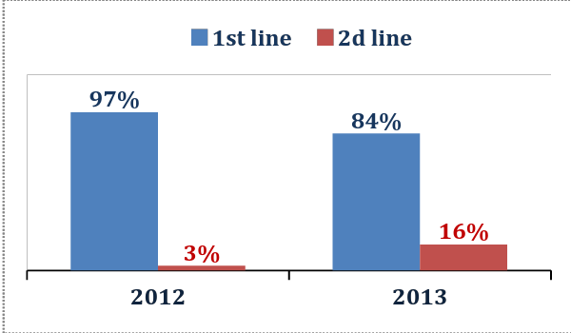 | 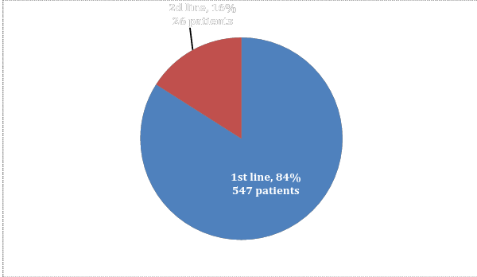
Diagram 1. Patients’ distribution depending  on АРТ regimens (the first and second line drugs) | Diagram 2. Patients’ distribution depending on ART regimens, 2013  (adults, who continue receiving ARV therapy, absolute values and %)

Adult patients’ distribution depending on ART regimens in 2013 is presented in Diagram 2.
The standard first line ART regimen consists of 2 NRTI and the third component which is 1 NNRTI or enhanced HIV protease inhibitor.
Percentage of different NRTI (AZT-, TDF or ABC-containing regimens in combination with 3ТС or FTC) in standard first line regimens depending on the number of adult patients receiving the following regimens at the end of 2013 is presented in Diagram 3. AZT- containing regimens constitute more than 57,6%, TDF-containing regimens constitute 39,5% and ABC- containing regimens constitute 2,9%.
The regimen of 3 NRTI (presented in Diagram 3 as AZT+ABC when the third component is 3TC) was prescribed to 3 adult patients only out of 479 patients receiving the first line ART regimen in 2013.
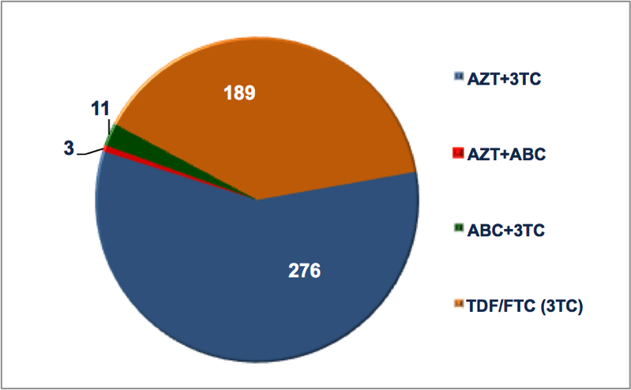 | 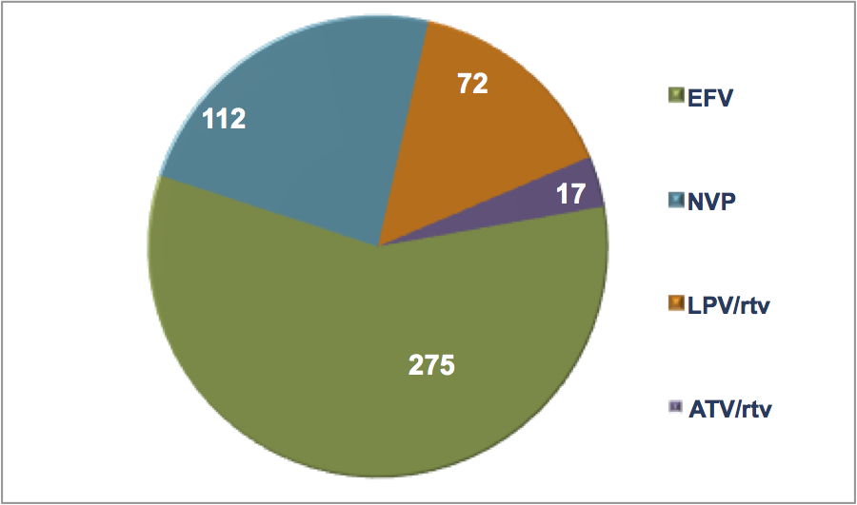
Diagram 3. Nucleoside basis  in the first line ART regimens, 2013  (adults, continue receiving ART) | Diagram 4. Non-nucleoside and HIV protease inhibitor in the first line ART regimens, 2013  (adults, continue receiving ART)

In 2013 percentage of NNRTI in the first line regimens was 80,8%. In 2013 the prevailing NNRTI in the first line ART regimens prescribed to adult patients was EFV (57% of all the first line ART regimens). ART regimens on the basis of enhanced HIV protease inhibitor (LPV/rtv -15,3%, ATV/rtv -3,5%) were prescribed to 18,6% of patients among those receiving the first line ART regimens in 2013. Percentage of NNRTI and HIV protease inhibitor in the first line ART regimens depending on the number of adult patients receiving the following regimens at the end of 2013 is presented in Diagram 4.
Preference is given to fixed dose combinations: AZT/3TC, TDF/FTC, ABC/3TC, LPV/rtv.. The above mentioned antiretroviral drugs are used in fixed dose combinations which in compliance with the existing international evidential basis increases patients’ adherence to treatment, complies with all the international recommendations including WHO approaches.
In 2012–2013 the average cost of the first as well as of the second line ART regimens is presented in Diagram 5 and in 2013 it constituted 311 USD per the first line ART regimen per one patient per year and 1061USD per the second line ART regimen per one patient per year.

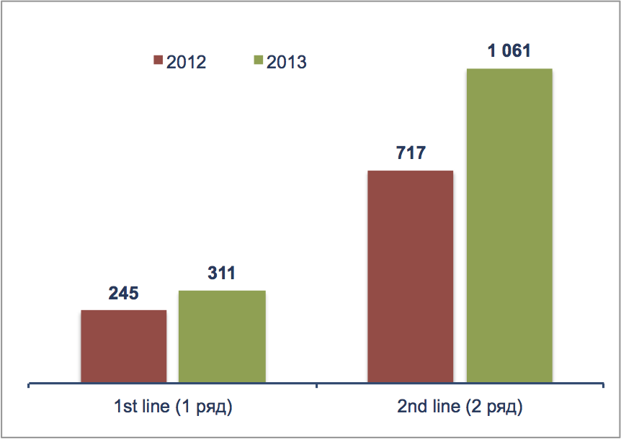
Diagram 5. The average cost of the first and second line ART regimens per patient per year, USD

ACCESS TO REGULAR AND QUALITATIVE SERVICES
The number of officially registered PWLH is 46,3% from the estimated number of PWLH in the country.
Notwithstanding that fact that percentage of PWLH who received early access to diagnosing CD4 (during 2 months after diagnosing the case) constituted 77% in 2011 and 84% in 2013, percentage of PWLH with the clinical symptoms or the number of CD4 < 350 cells/mcL at the moment of diagnosing HIV infection was 45,8% in 2013. This indicator might serve as the evidence of late diagnosing HIV infection and consequently causes untimely late ARV therapy start as well as expenditures on seriously ill patients.
Simplified technologies of identifying the number of CD4 are unavailable in the process of identifying HIV infection at the level of PWLH in general as well as at the level of PWLH from separate key vulnerable groups at the local, regional and national levels.
Early and systematic access to diagnosing and identifying the number of CD4 for all PWLH is not only one of essential conditions of ART start on the basis of immunological criterion but also factor which influences further indicators of treatment efficiency.
The indicators of patients’ retention on ART remain stable: 83,3% after 12 months of therapy. In 2013 the indicator of retention on therapy after 60 months was 74,2%.
Detailed analysis of number of patients on different regimens noticed some discrepancy between reported data on number of patients receiving ART at the end of the year and data calculated based on the number of patients at each regimen. According to the report of the Republican Center to fight AIDS the number of adults (at the age of 15+) receiving ART at the end of the reporting period is 564 people, the number of adults (at the age of 15+) receiving ART regimens at the end of the reporting period, on regimens is 573 people (+9).
The absence of cases of therapy interrupting with at least one patient lasting more than a week in a year might suggest thorough monitoring of antiretroviral drugs according to ART regimens, the number of patients receiving separate ART regimens and their components, the effective work of monitoring and supply chain, its connection to the system of biofeedback which in its turn allows to provide regular ARV therapy for all patients who received access to treatment.
The same time, monitoring and reporting of treatment interruption due to the stock-out issues need to be analyzed more in-depth.

TABLE 4. INDICATORS OF ART CONTINUITY AND EFFECTIVENESS
 | 2011 | 2012 | 2013
Percentage of PWLH continuing receiving ART after 12 months, % | 83,3 | 84 | 84.4
Percentage of PWLH continuing receiving ART after 60 months, % | 84 | 72.5 | 74.2
The number of stock-outs which would happen to at least 1 patient and last more than a week in the course of a year | 0 | 0 | 0
The number of patients on ART checking their viral load at least once a year | 266 | 430 | 522
The number of patients with the unidentified viral load |  |  | 428

The current National Clinical Protocols approved by the Ministry of Health prescribe systematic monitoring of the viral load (VL) to all HIV infected patients on ART not less than 2 years at intervals of once per 6 months, to patients on ART not less than 2 years when there wasn’t any case of virological failure at intervals once per 12 months to prove virological efficacy of therapy and patients’ adherence to treatment.
The indicator of VL which is equal to 25 copies RNA HIV/ml of plasma serves the threshold of sensitivity to the used test systems in the country. In case when VL is < 25 copies RNA HIV/ml of plasma it’s “unidentified”.
Viral load testing is available only at the Republican Centre to prevent HIV/AIDS which is the only health care institution in the country providing ART and is carried out not less than once a year for all patients receiving ART. The percentage of patients with unidentified viral load among those on treatment is 76% (428 out of 564).
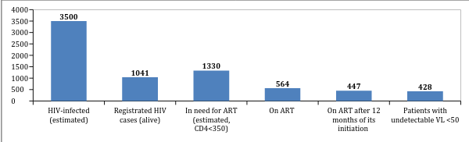
Diagram 6. PWLH access to regular effective health care services (2013)

FUNDING OF HIV/AIDS PROGRAMS

A constant decrease (in absolute values) in funding programs to fight HIV infection one can be observed in the Republic of Armenia in 2011–2013. Percentage of international donors funding (the Global Fund to fight AIDS, tuberculosis and malaria, the Russian Federation, international organizations, UN agencies) increased. In comparison to 2011 in 2013 percentage of external funding 15,8% increased and constituted 4/5 of the overall annual allocated budget.

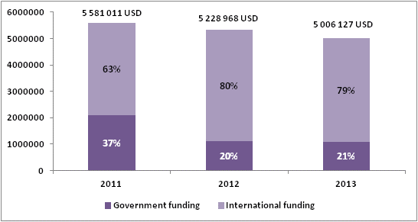

Diagram 7. The overall annual expenditures to fight
HIV epidemic, USD and %

27% of the overall budget allocated to fight HIV epidemic was used to fund programs of PWLH treatment and support in 2013. Government budget covered almost the third of all the expenditures and that was 34%, in 2011 this number was 24% and in 2012 it was 41%. ART was procured on the funds of international donors only. (Diagram 8).

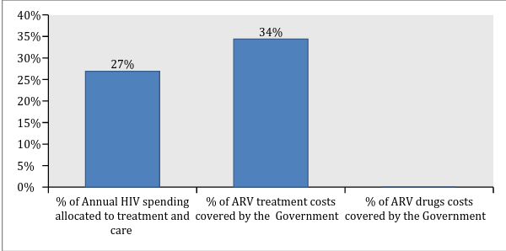
Diagram 8. Funding of treatment and support programs, %
CONCLUSIONS
The indicators of HIV prevalence imply stabilization of the epidemic process among risk groups in the Republic of Armenia, although no indication of overall stabilization of HIV epidemic in the country. The number of officially registered PWLH is 46,2% from the estimated number of PWLH in the country. Therefore, more than 50% of all the cases of HIV infection remain unidentified. Tests coverage among risk groups continues its growth though it’s still insufficient.
ART coverage has been constantly growing which resulted in improvement of the number of AIDS mortality cases. Though taking a high number of unidentified PWLH and late cases of HIV infection diagnosing into consideration indicators of the universal access to treatment are insufficient for treatment to perform prevention function.
In 2013 ART procurement was realized due to the funds of international donors (the Global Fund to fight AIDS, tuberculosis and malaria, the Russian Federation, international organizations and UN agencies). The country would have to increase its expenditures on the further programs from the overall and local budgets to fight HIV epidemic in order to be able to introduce government funding in the nearest future.
Percentage of adult patients receiving the first line ART regimens constituted 97% from all adult PWLH receiving ARV therapy in 2012 and 84% in 2013.
All patients receive standard ART regimens. In 2013 percentage of the first line ART regimens based on NNRTI was 81%. In 2013 the prevailing NNRTI in the first line ART regimen prescribed to adult patients was EFV (57%) while more than 24% of patients on the first line ART regimens received ART regimens based on NNRTI-NVP. ARV therapy is prescribed in the form of fixed dose combinations including three component regimens of the first line based on NNRTI, which in its turn is in compliance with the existing international evidential database increases patients’ adherence to treatment and complies with all the international recommendations including WHO approaches.
The number of reported patients continuing receiving ART does not coincides with the number of ARV drugs and ARV components in ART regimens which demonstrates thorough monitoring and reliable data.
Quantitative data analysis of annually registered cases of HIV and AIDS and AIDS death cases is essential in the process of general assessment of the epidemic situation with HIV infection. While collecting and analyzing data provided by the surveillance it’s important to implement some tool which will allow their disaggregation for identifying their structure and data analysis of newly registered cases of HIV infection, disease incidents, death via their clinical epidemiological indicators including key epidemiological indicators, such as belonging to particular vulnerable groups and clinical epidemiological indicators: stage of HIV infection and level of CD4 at the moment of diagnosing the case, data on the structure of AIDS defining illnesses, causes of death of PWLH: related to HIV, not related to HIV, because of AIDS defining illnesses or some other diseases/conditions which served the cause for death and when cause of death remains undetermined.
Available clinical epidemiological characteristics of key epidemiological data on disease prevalence and death cases among PWLH are important for development and assessment of effective measures to respond the epidemic.

RECOMMENDATIONS

HIV Testing Accessibility
- The system of HIV testing monitoring should include not only tests volume but also the structure of these tests (by gender and age).
- It’s necessary to increase percentage of HIV tests carried out among risk groups and their intercourse partners, improve access to tests among key vulnerable groups, identify effective “entry points” of access to counseling and testing which gives the opportunity to shorten the difference between estimated and registered number of PWLH.
- It’s important to introduce/implement data collection and analysis reflecting connection of the number of HIV tests in separate groups with the number of newly registered PWLH from these groups and with those who received access to CD4 analysis and other services of treatment, care and support including ART for the particular reporting period. The following approach gives the opportunity to receive and evaluate information about HIV testing efficacy.
Epidemiological and Clinical Monitoring
- It’s highly recommended to collect data on HIV tests, the number of newly registered cases of HIV infection, AIDS, mortality of PWLH, and AIDS related mortality applying methods and tools allowing to identify the structure of the following data as well as to conduct analysis on the basis of clinical epidemiological characteristics including key epidemiological indicators (belonging to particular vulnerable to HIV infection groups among them) as well as clinical epidemiological indicators such as HIV infection stage and the number of CD4 at the moment of diagnosing HIV infection, HIV infection stage and the number of CD4 at the moment of ART start, access to ARV therapy (if there has been a new case of AIDS defining disease or death in the course of receiving ART or while being out of this access), ART duration.
- To introduce data collection and coverage evaluation of CD4 among general population of PWLH and PWLH who are representatives of key vulnerable groups while diagnosing HIV infection and in the course of follow-up.
- To introduce data monitoring and analysis on the structure of AIDs defining diseases.
- To conduct data collection which allows their disaggregation and analysis on the reasons of PWLH deaths: cases related to HIV infection, those which are not related to HIV, because of AIDS defining diseases or some other diseases/conditions which served the cause of death, as well as deaths of PWLH when the cause has been unidentified.
- It’s necessary to implement methodology of triangulation data analysis (recommended by UNAIDS/WHO, 2013) in order to prove the main tendencies of the epidemic process of HIV infection. The above mentioned methodology implies collection and analysis of quantitative and qualitative data received from several sources using different methods of information collection which gives the opportunity to receive more reliable data of evaluation of the epidemic situation with HIV infection among general population as well as among different social and vulnerable to HIV infection groups.
Access to ART
- It’s necessary to scale up access to treatment programs for PWLH supported by both the government funds and the funds of international donors.
- To provide early access of newly registered PWLH to diagnosing the number of CD4 cells 4 possibly with the use of simplified technologies of rapid identification of CD4 number.
- To approximate substitution therapy to ART for PWID in need of integrated help.
- According to data provided by the protocols 2014 taking the increasing ART for PWLH into consideration it’s recommended to consider the possibility of the increase in the range of services provided as well as regular medical check-up for PWLH (decentralization of medical services and integration of the services needed in place of provision of the following services).
- To consider possibility of opening sites of integrated services for PWLH/PWID at health care institutions providing treatment to PWLH.
- To introduce monitoring and analysis of CD4 median level at the moment of ART start which would allow precise evaluation of timely access to ART.
- To improve the systems of clinical monitoring of all patients receiving ART and, specifically, of timely record of patients dropped out of the treatment program with the analysis of the dropout’s reasons/causes (patient’s death, ART interruption for some other reasons, causes identification and analysis). It will allow a more precise identification of the number of patients receiving ART in the course of some separate period (e.g. 12 months, 24 months, 60 months), based on the cohorts’ analysis.
- To improve relation of the system of biofeedback to procurement and supply chain based on the importance of providing regular ART for those patients who have already received access to treatment within those regimens they receive and don’t demonstrate any signs of inefficiency or intolerance.
- To improve planning systems of access to ART scale up and relation of planning to procurement and supply chain based on the importance of access to ART for those patients who need it in compliance with the current National Clinical Protocol.
- To introduce monitoring of indicators of early prevention of antiretroviral resistance in compliance with WHO recommendations at health care institutions at the local, regional and national levels:
- ART prescription
- Patients lost/dropped out of the follow up during the first 12 months (absolute number and %);
- Patients continuing receiving the first line ART regimen after 12 months of treatment;
- Following schedule of attending health care institutions to receive ART;
- Timely receipt of ART;
- Regular procurement and uninterrupted supply of ARV drugs.

ABBREVIATIONS

ARV – antiretroviral, ART – antiretroviral therapy, CSW – commercial sex workers, MSM – men who have sex with men, GF – Global Fund, n/d – no data available, PWID – people who inject drugs, PWLH – people living with HIV, TB – tuberculosis, VL – viral load.

ACKNOWLEDGMENTS

Research team is grateful to Samvel Grigoryan and Arshak Asmaryan, the representatives of AIDS Сentre in the Republic of Armenia, for their assistance in data collection and participation in the review of this document.

