Antiretroviral therapy. THE REPUBLIC OF KAZAKHSTAN

EPIDEMIOLOGICAL CONTEXT

HIV/AIDS Incidence and Prevalence and AIDS Mortality.
Over a period of time 1987–2013 there were 19 905 cases of HIV infection registered in the Republic of Kazakhstan (cumulative data). The estimated number of PWLH in the country constituted 19 000 people in 2013. Though, the country has taken the decision to refuse adoption of estimated by “Spectrum” data. The HIV prevalence indicators and the number of newly registered cases of HIV infection over the last three years imply stabilization of the epidemiological process in the Republic of Kazakhstan. Epidemic of HIV infection has been still concentrated among risk groups though the current situation among risk populations can be also characterized by stabilization (Table 1).
TABLE 1. MAIN EPIDEMIOLOGICAL INDICATORS
 | 2011 | 2013
The estimated number of PWLH | 16 000 | 19 000
HIV prevalence among adults (at the age of 15-49 years old),% | 0.13 | 0.16
HIV spread among PWID according to sentinal surveillance data, % | 3.8 | 4.8
HIV prevalence among MSM according to sentinal surveillance data, % | 1 | 1.2
HIV prevalence among CSW according to sentinal surveillance data, % | 1.5 | 1.5
The number of newly registered cases of HIV infection | 1 835 | 1 995
HIV incidence, per 100 000 people | 11.3 | 11.7
Percentage of officially registered PWLH from the estimated number, % | 69 | 69
AIDS case rate, per 100 000 people | 1.45 | 1.46
AIDS related death, per 100 000 people | 4.8 | 4.2

Against the background of increase of access to ART the indicators of annually registered cases of AIDS and AIDS related death have the tendency to stabilization.

HIV TESTING ACCESSIBILITY

In 2013 the overall number of HIV tests was 2 398 537 which meant that there were 14 077 tests per 100 000 people. The average annual increase in the number of tests is 5%–6%. Routine surveillance data on tests reflect their intensity and expenditures though these data are rather limited as far as structure analysis by gender, age and belonging to some risk groups is concerned. The share of the representatives from risk groups among those tested for HIV constituted about 2%–3 % in 2013 (Table 2).

TABLE 2. HIV TESTING INDICATORS
 | 2011 | 2013
The overall number of HIV tests per 100 000 people | 13 617 | 14 383
The number of HIV tests among key vulnerable groups (PWID, МSМ, CSW, migrants and prisoners)
PWID | 26 246 | 34 427
CSW | 397 | 791
МSМ | 8 187 | 7 348
migrants | n/d | n/d
% of pregnant women tested for HIV over the last 12 months and aware of their results | 99.8 | 98
% of patients with TB aware of their HIV positive status | 85 | 91

Notwithstanding the high level of migration in the country there is no data available on the number of tests among migrants.
The level of HIV testing coverage among pregnant women remains rather high (98% and more). HIV testing among patients with TB indicates the slight increase. In 2013 91% of patients with TB were aware of their HIV status.

ACCESS TO ART

In the Republic of Kazakhstan there are 23 health care institutions providing ART. All 23 health care institutions providing treatment to PWLH provide TB diagnostics.
In 2013 the share of HIV infected PWID among adult PWLH who had received access to ART was 52.3%.
6 sites in the country provided integrated services for PWLH/PWID (ART and substitution therapy). At the end of 2013 22 PWID received ART and substitution therapy.
The scale up of access to ART (from 1 583 to 3 240 people) among adult PWLH was observed in 2011–2013. In 2013 the total ART coverage constituted 17.1% from the estimated number of PWLH in the country and has shown the a tendency to increase (in comparison to 9.9% in 2011). In 2013 году 3 240 PWLH out of 10 090 adult patients of the dispensary group, 32.1 % of those PWLH who had visited health care institution at least once in the reported year received ARV therapy (Table 3).

TABLE 3. ACCESS TO ARV THERAPY AND MEDICAL FOLLOW UP

 | 2011 | 2012 | 2013
The number of adults (at the age of 15+) receiving ARV therapy at the end of the year | 1583 | 2338 | 3240
Percentage of adults (at the age of 15+) receiving ARV therapy from the estimated number of PWLH, % | 9.9 | 13.3 | 17.1
Adults’ percentage (at the age of 15+) receiving ARV therapy from the number of the dispensary group, % | 19.5 | 25.6 | 32.1
The number of PWID receiving ART | n/d | n/d | 1695
The number of representatives from other key vulnerable groups receiving ART | No data available
Percentage of PWID among adults (at the age of 15+) receiving ARV therapy, % | n/d | n/d | 52.3
Percentage of representatives from other key vulnerable groups receiving ART | No data available
The number of HIV infected PWID receiving ARV and substitution therapy | n/d | n/d | 22
Percentage of PWLH tested for CD4 level at the moment of diagnosing the case (in the course of 2 months after diagnosing the case), % | 99.6 | 62.6 | 56.4
Percentage of PWLH with the clinical symptoms and CD4 < 350 at the moment of diagnosing the case, % | 48 | 48 | 40
The average level of CD4 among patients at the moment of starting ARV therapy | No data available

The current National Clinical Protocols approved by the Ministry of Health prescribe systematic monitoring of the level of CD4 for all HIV patients, which helps to solve the issues related to the start of ARV therapy as well as opportunistic infections prevention.
In 2013 in compliance with the National Protocol the immunological threshold for starting ARV therapy was the level of CD4 < 350 cells/mcL.
In 2013 percentage of PWLH with the clinical symptoms or the number of CD4 <350 cells/mcL at the moment of diagnosing HIV infection was 40%. Simplified technologies of identifying the level of CD4 are unavailable at the level of diagnosing HIV infection as well as at the level of PWLH population, PWLH from separate key vulnerable groups at the local, regional and national levels. Some health care institutions providing services to PWLH have an option of CD4 analysis before ART start, which performs the function of the routine survey. However it should be noted that the indicator of CD 4 at the moment of diagnosing HIV infection, in the process of medical check-up, at the moment of ART start at the level of PWLH as well as at the level of health care institutions (locally, regionally and nationally) wasn’t included into the system of monitoring and evaluation.
Therefore the current system of biofeedback at the level of health care institutions providing services to PWLH at the local, regional and national levels doesn’t provide the opportunity for getting timely data on patients’ distribution on the number of their CD4 at the moment of ARV therapy start, for identifying the median/midpoint of the number of CD4 at the moment of ART start at the local, regional, national levels and at the level of particular health care institutions.

ART AND PROCUREMENT SERVICES

ARV therapy is provided to “naive” as well as to already exposed to ARV treatment patients in compliance with the current National Clinical Protocol approved by the Ministry of Health.
In compliance with the National Clinical Protocol the first line ART regimens include ART regimens prescribed to “naïve” patients for the very first time in their life as well as “substitution” regimens when separate components of initially prescribed regimen are substituted as the result of toxicity/intolerance to some ARV drugs. All patients on the first line ART regimens receive standard three component regimens.
The second line ART regimens are those prescribed in case of failure in use of the first line SRVT regimens when the first line ARV regimen is substituted by the second line ART regimen. Failure in ART” means existence of some virological, immunological and clinical symptoms of treatment failure. The described approach complies with the recommendations of WHO.
Percentage of adult patients receiving the first line ART regimens constituted 99% from all adult patients among PWLH receiving ARV therapy in 2012 and 98% in 2013.
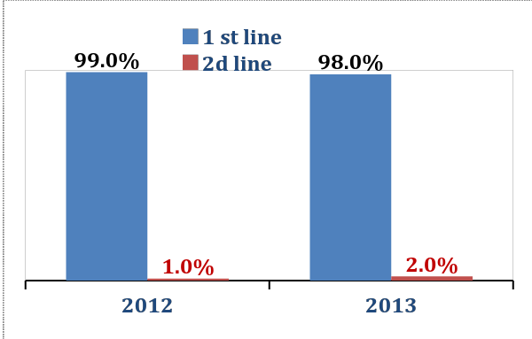
Diagram 1. Patients’ distribution depending on  The first and second line ART regimens, % | Diagram 2. Patients’ distribution depending on ART regimens, 2013  (adults, who continue receiving ARV therapy, %)

Adult patients’ distribution depending on ART regimens in 2013 is presented in Diagram 2.
The standard first line ART regimen consists of 2 NRTI and the third component which is 1 NNRTI.
Percentage of different NRTI (AZT-, TDF- in combination with 3ТС or FTC) in standard first line regimens depending on the number of adult patients receiving the following regimens at the end of 2013 is presented in Diagram 3. AZT- containing regimens constituted 96%, TDF-containing regimens constituted 4%.
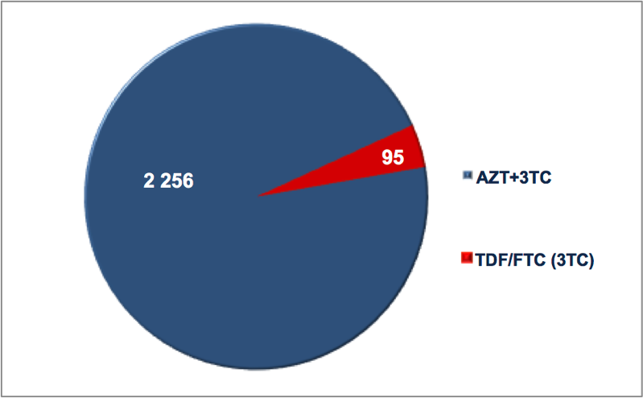 | 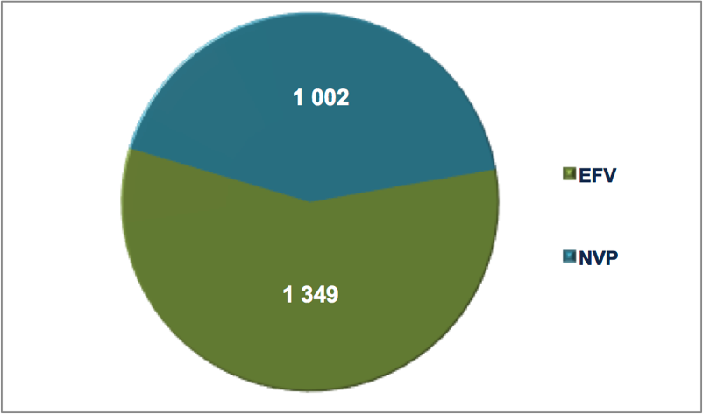
Diagram 3. Nucleoside basis in the first line ART regimens, 2013 (adults, continue receiving ART) | Diagram 4. Non-nucleoside in the first line ART regimens, 2013 (adults, continue receiving ART)

In 2013 percentage of NNRTI in the first line regimens was 100%. In 2013 the prevailing NNRTI in the first line regimens prescribed to adult patients was EFV (57.4% of all the first line ART regimens), in 42.6% of NNRTI the basis for the first line ART regimen served NVP. ART regimens on the basis of enhanced HIV protease inhibitor were not prescribed to patients receiving the first line ART regimens.
Preference is given to fixed dose combinations: AZT/3TC, TDF/FTC. The above mentioned antiretroviral drugs are used in fixed dose combinations which in compliance with the existing international evidential basis increases patients’ adherence to treatment, complies with all the international recommendations including WHO approaches.
In 2012–2013 the average cost of the first as well as of the second line ART regimens is presented in Diagram 5 and in 2013 it constituted 944 USD per the first line ART regimen per one patient per year and 1627 USD per the second line ART regimen per one patient per year.
Diagram 5. The average cost of the first and second line ART regimens
per one patient per year, USD

ACCESS TO REGULAR AND QUALITATIVE SERVICES

The percentage of PWLH with the clinical symptoms or the number of CD4 < 350 cells/mcL at the moment of diagnosing HIV infection constituted 40% in 2013. The above mentioned indicator might serve as the evidence of late diagnosing HIV infection and consequently causes untimely late ARV therapy start as well as expenditures on seriously ill patients.
Simplified technologies of identifying the number of CD4 are unavailable in the process of identifying HIV infection at the level of PWLH in general as well as at the level of PWLH from separate key vulnerable groups at the local, regional and national levels.
Early and systematic access to diagnosing and identifying the number of CD4 for all PWLH is not only one of essential conditions of ART start on the basis of immunological criterion but also factor which influences further indicators of treatment efficiency. As mentioned before the indicator reflecting the average number of CD4 at the moment of ART start hasn’t been included into the system of monitoring and evaluation.
The indicators of patients’ retention on ART remain stable: 74.8% of patients continue ART after the start. The rate of retention on therapy after 60 months improved and constituted 66.5% in 2013.
Detailed analysis of number of patients on different regimens noticed some discrepancy between reported data on number of patients receiving ART at the end of the year and data calculated based on the number of patients at each regimen. According to the report of the Republican AIDS Center the number of adults (at the age of 15+) receiving ART at the end of the reporting period is 3240 people, the number of adults (at the age of 15+) receiving ART regimens at the end of the reporting period is 2388 people. (-852).
The absence of cases of therapy interrupting with at least one patient lasting more than a week in a year might suggest thorough monitoring of antiretroviral drugs according to ART regimens, the number of patients receiving separate ART regimens and their components, the effective work of monitoring and supply chain, its connection to the system of biofeedback which in its turn allows to provide regular ARV therapy for all patients who received access to treatment.
The same time, monitoring and reporting of treatment interruption due to the stock-out issues need to be analyzed more in-depth.

TABLE 4. INDICATORS OF ART CONTINUITY AND EFFECTIVENESS
 | 2011 | 2012 | 2013
Percentage of PWLH continuing receiving ART after 12 months, % | 64 | 81 | 74.8
Percentage of PWLH continuing receiving ART after 60 months, % | 41 | 37.8 | 66.5
The number of stock-outs which would happen to at least 1 patient and last more than a week in the course of a year | 0 | 0 | 0
The number of patients on ART checking their viral load at least once a year | 1462 | 2410 | 3093
The number of patients with the unidentified viral load. | Data is not available |  | 2111

The current National Clinical Protocols approved by the Ministry of Health prescribe systematic monitoring of the viral load (VL) for all HIV infected patients on ART at intervals of once per 6 months to prove virological efficacy of therapy and patients’ adherence to treatment.
The indicator of VL which is equal to 25 copies RNA HIV/ml of plasma serves the threshold of sensitivity to the used test systems in the country. In case when VL is < 25 copies RNA HIV/ml of plasma it’s “unidentified”.
Viral load testing is available only at one health care institution providing ARV therapy and is tested not less than once a year for patients receiving ART. The percentage of patients with unidentified viral load among those on treatment is 65% (2111 out of 3240).
Diagram 6. PWLH access to regular effective health care services (2013)

FUNDING OF HIV/AIDS PROGRAMS

An inconsiderable increase (in absolute values) in funding programs to fight HIV infection can be observed in the Republic of Kazakhstan over the past two years. The ratio between government funding and funds allocated by international donors remains practically at the same level: the share of state budget constitutes approximately 4/5 from the overall annually allocated budget.
Diagram 7. The overall annual expenditures to fight
HIV epidemic, USD and %

In 2013 80% of the overall budget allocated to fight the epidemic of HIV infection was used to fund the programs of PWLH treatment and support. Starting from 2009 ART, ART procurement for adults in Kazakhstan has been fully managed by the government funds.

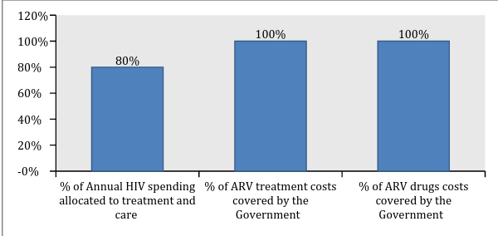
Diagram 8. Funding of treatment and support programs, 2013, %

CONCLUSIONS

The range of some indicators including the indicators of HIV prevalence and spread imply stabilization of the epidemic process in the Republic of Kazakhstan. The epidemic process has been still concentrated among vulnerable groups though it shows all signs of stabilization.
The system of HIV infection routine monitoring doesn’t allow thorough monitoring and analysis of all the indicators among the above mentioned groups. Because of routine monitoring limitations it’s difficult to evaluate ART coverage among vulnerable groups (excluding PWID).
ART coverage has been constantly growing which resulted in improvement of indicators of AIDS prevalence and AIDS mortality. Though taking late cases of HIV infection diagnosing into consideration indicators of the universal access to treatment are insufficient for treatment to perform prevention function.
The number of reported patients continuing receiving AVT doesn’t coincide with the number of ARV drugs and ARV components in ART regimens. However, the absence of cases of treatment interruption indicates that monitoring of antiretroviral drugs is functional.
ARV treatment in the Republic of Kazakhstan is fully covered by the state budget.

In 2011 percentage of adult patients receiving the first line ART regimens constituted 99% from all adult PWLH receiving ARV therapy and in 2013 this indicator was 98%. All patients receive standard ART regimens.
In 2013 percentage of the first line ART regimens based on NNRTI was 100%. In 2013 the prevailing NNRTI in the first line ART regimen prescribed to adult patients was EFV (57,4%) while more than 42,6% of patients on the first line ART regimens received ART regimens based on NNRTI-NVP. ARV therapy is prescribed in the form of fixed dose combinations including three component regimens of the first line based on NNRTI which in its turn in compliance with the existing international evidential database increases patients’ adherence to treatment and complies with all the international recommendations including WHO approaches.
Quantitative data analysis of annually registered cases of HIV, AIDS and AIDS mortality cases are essential in the process of general assessment of the epidemic situation with HIV infection. While collecting and analyzing data provided by the surveillance it’s important to implement some tool which will allow their disaggregation for identifying the structure and data analysis of newly registered cases of HIV infection, disease incidents, death via their clinical epidemiological indicators including key epidemiological indicators, such as belonging to particular vulnerable groups and clinical epidemiological indicators: stage of HIV infection and level of CD4 at the moment of diagnosing the case, data on the structure of AIDS defining illnesses, causes of death of PWLH: related to HIV, not related to HIV, because of AIDS defining illnesses or some other diseases/conditions which served the cause for death and when cause of death remains undetermined.
Available clinical epidemiological characteristics of key epidemiological data on disease prevalence and death cases among PWLH are important for development and assessment of effective measures to respond the epidemic.

RECOMMENDATIONS

HIV Testing Accessibility
- The system of HIV testing monitoring should include not only tests volume but also the structure of these tests (by gender and age). Monitoring of tests structure among vulnerable groups needs improvement.
- It’s necessary to increase percentage of HIV tests carried out among risk groups and their intercourse partners, improve access to tests among key vulnerable groups, identify effective “entry points” of access to counseling and testing which gives the opportunity to shorten the difference between estimated and registered number of PWLH.
- It’s important to introduce/implement data collection and analysis reflecting connection of the number of HIV tests in separate groups with the number of newly registered PWLH from these groups and with those who received access to CD4 analysis and other services of treatment, care and support including ART for the reporting period. The following approach gives the opportunity to receive and evaluate information about HIV testing efficacy.

Epidemiological Monitoring and Biofeedback
- It’s highly recommended to collect data on HIV tests, the number of newly registered cases of HIV infection, AIDS, and mortality of PWLH, and AIDS related applying methods and tools allowing to identify the structure of the following data as well as to conduct analysis on the basis of clinical epidemiological characteristics including key epidemiological indicators (belonging to particular vulnerable to HIV infection groups among them) as well as clinical epidemiological indicators such as HIV infection stage and the number of CD4 at the moment of diagnosing HIV infection, HIV infection stage and the number of CD4 at the moment of ART start, access to ARV therapy (if there has been a new case of AIDS defining disease or death in the course of receiving ART or while being out of this access), ART duration.
- To introduce data collection and coverage evaluation of CD4 among general population of PWLH and PWLH who are representatives of key vulnerable groups while diagnosing HIV infection and in the course of follow-up.
- To introduce data monitoring and analysis on the structure of AIDs defining diseases.
- To conduct data collection which allows their disaggregation and analysis on the reasons of PWLH death: those cases related to HIV infection, those which are not related to HIV, because of AIDS defining diseases or some other diseases/conditions which served the cause of death, as well as death of PWLH when the cause has been unidentified.
- It’s necessary to implement methodology of triangulation data analysis (recommended by UNAIDS/WHO, 2013) in order to prove the main tendencies of the epidemic process of HIV infection. The above mentioned methodology implies collection and analysis of quantitative and qualitative data received from several sources using different methods of information collection which gives the opportunity to receive more reliable data of evaluation of the epidemic situation with HIV infection among general population as well as among different social and vulnerable to HIV infection groups.

ART Accessibility
- It’s necessary to scale up access to treatment programs for PWLH due to the government funds.
- It’s important to provide early access of newly registered PWLH to diagnosing the number of CD4 cells - possibly with the use of simplified technologies of rapid identification of CD4 number.
- To approximate substitution therapy to ARV therapy for those PWID in need of integrated services by increasing the number of sites of integrated services for PWLH/PWID at health care institutions providing treatment to PWLH.
- To provide access to systematic routine survey of CD4 number and viral load for all PWLH from the dispensary group at intervals approved by the National Clinical Protocol.
- To introduce monitoring and analysis of CD4 mid level at the moment of ART start at health care institutions providing services to PWLH at the local, regional and national levels which would allow precise evaluation of timely access to ART.
- To improve the systems of clinical monitoring of all patients receiving ART and, specifically, of timely record of patients dropped out of the treatment program with the analysis of the dropout’s reasons/causes (patient’s death, ART interruption for some other reasons, causes identification and analysis). It will allow a more precise identification of the number of patients receiving ART in the course of some separate period (e.g. 12 months, 24 months, 60 months), based on the cohorts’ analysis.
- To improve relation of the system of biofeedback to procurement and supply chain based on the importance of providing regular ART for those patients who have already received access to treatment within the regimens they receive and there are no signs of inefficiency or intolerance.
- To improve planning systems of access to ART scale up and relation of planning to procurement and supply chain based on the importance of access to ART for those patients who need it in compliance with the current National Clinical Protocol.
- To introduce monitoring of indicators of early prevention of antiretroviral resistance in compliance with WHO recommendations at health care institutions at the local, regional and national levels:
  - ART prescription
  - Patients lost/dropped out of the follow up during the first 12 months (absolute number and %);
  - Patients continuing receiving the first line ART regimen after 12 months of treatment;
  - Following schedule of attending health care institutions to receive ART;
  - Timely receipt of ART;
  - Regular procurement of ARV drugs.
- To improve the system of complex (medico-social) approach to PWLH treatment (help patients realize the importance of systematic check-up, existence of effective record system of attending health care institutions, sufficient level of case management and support (oriented on individual patient’s needs) of HIV infected patients, support of patients’ adherence to treatment) aiming at forming a higher level of adherence to ART.

ABBREVIATIONS

ARV – antiretroviral, ART – antiretroviral therapy, CSW – commercial sex workers, MSM – men who have sex with men, GF – Global Fund, n/d – no data available, PWID – people who inject drugs, PWLH – people living with HIV, TB – tuberculosis, VL – viral load.

ACKNOWLEDGMENTS

Research team is grateful to Rafail Kipshakbayev, the representative of AIDS Centre in the Republic of Kazakhstan, for his assistance in data collection and participation in the review of this document.

